Tour ID: 259161  
Tour Name: Cruising Under the Midnight Sun

Tour destinations: ['Reykjavik']

Tour destinations images:

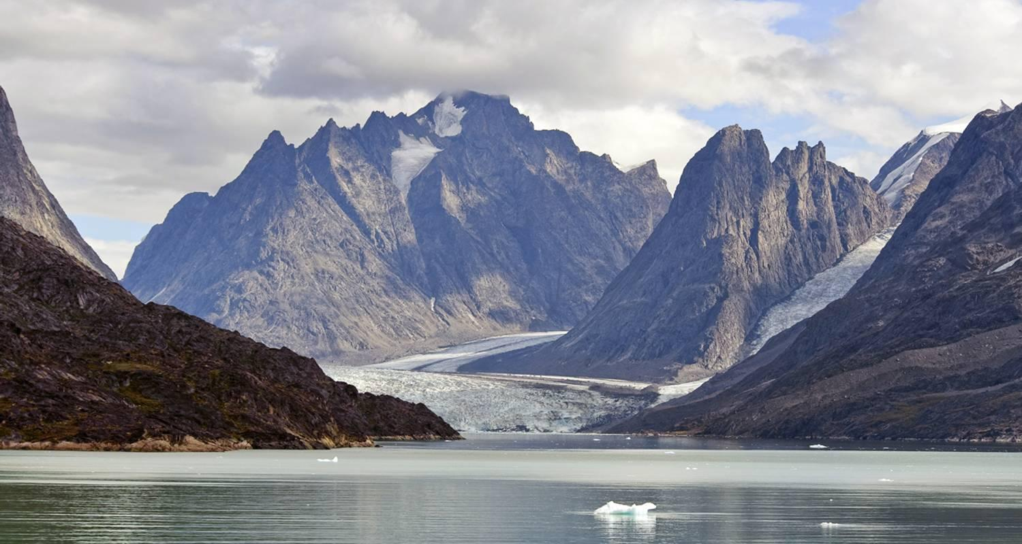

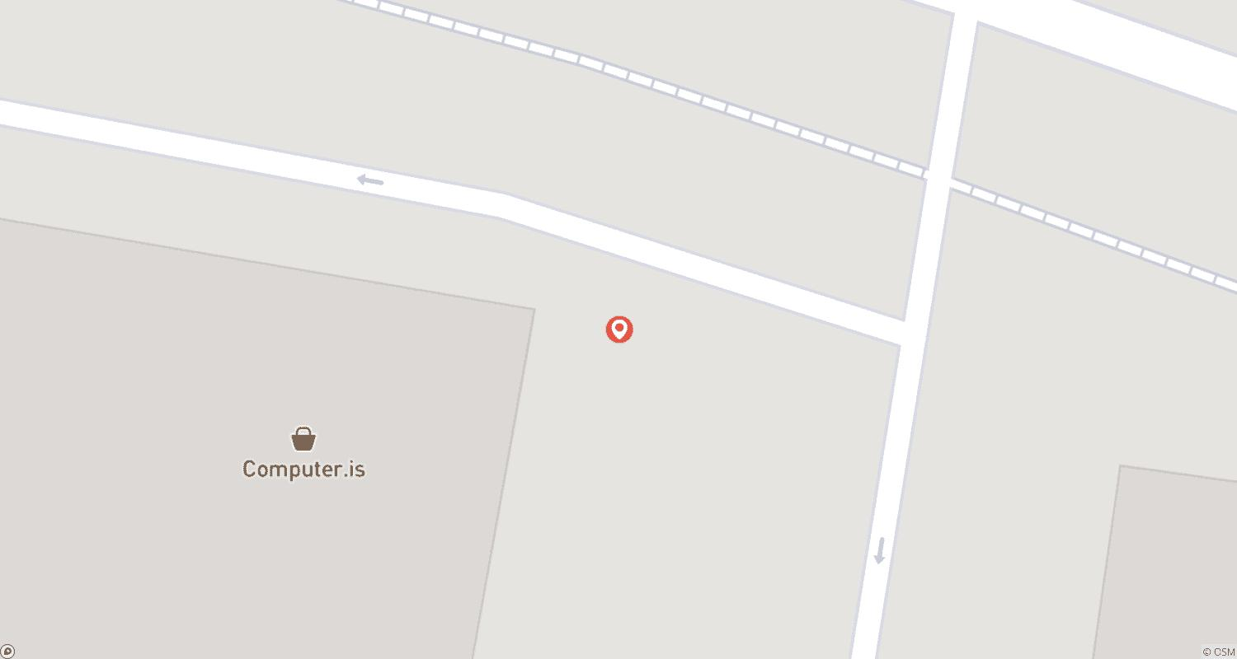

Tour ID: 259168  
Tour Name: In the Wake of the Great Explorers | Westbound

Tour destinations: ['Reykjavik', 'Ivittuut', 'Nuuk', 'Baffin Island', 'Gjoa Haven', 'Cambridge Bay', 'Nome', 'Vancouver']

Tour destinations images:

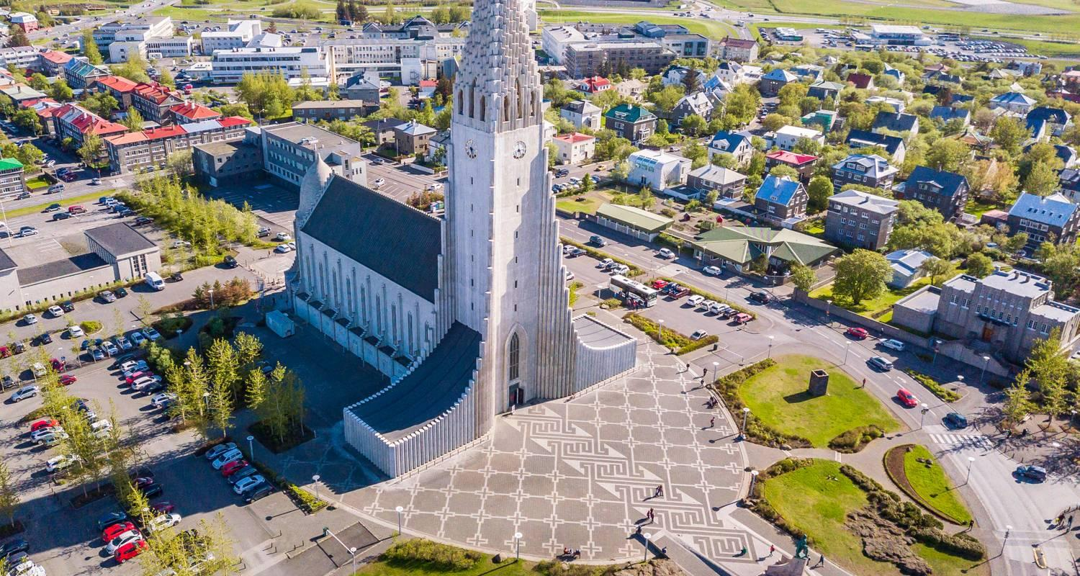

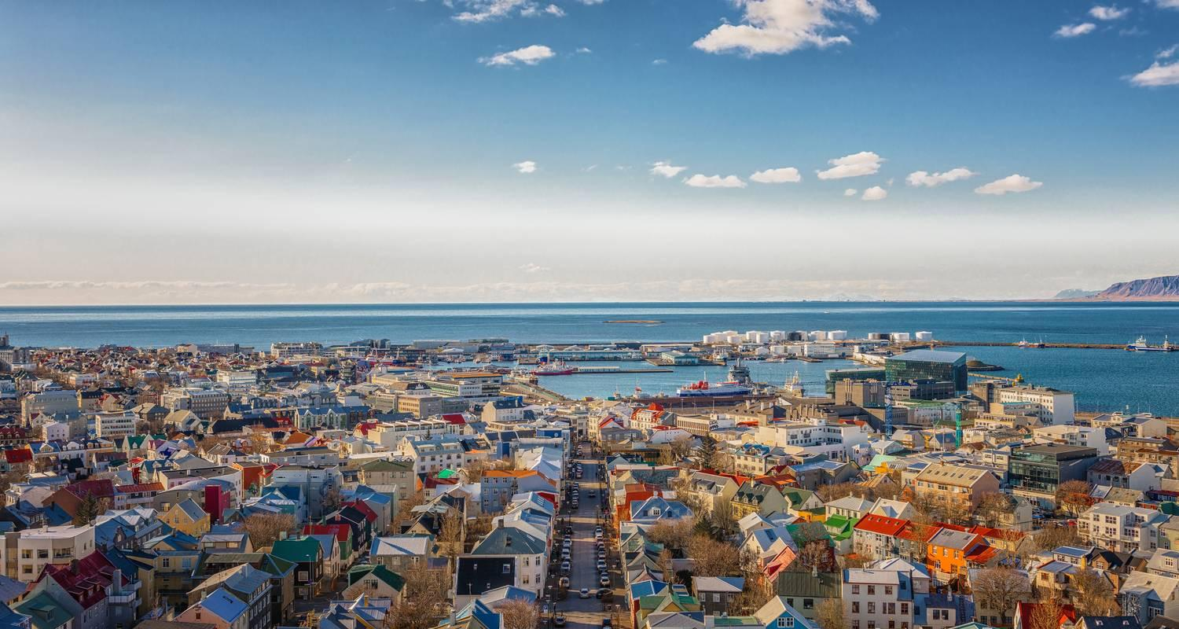

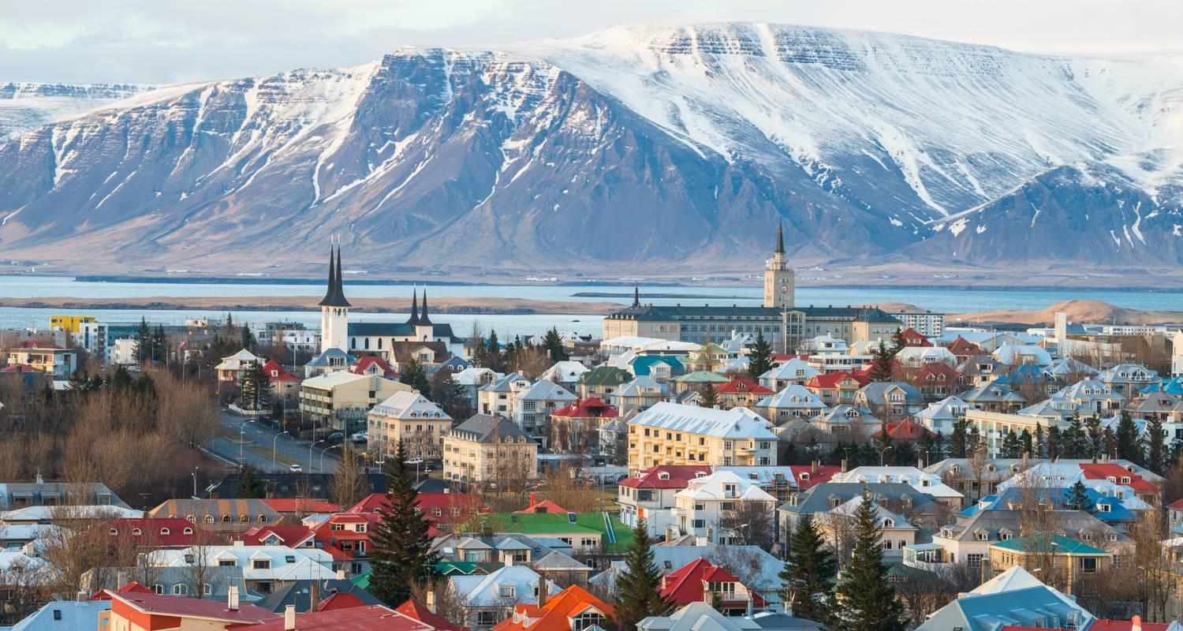

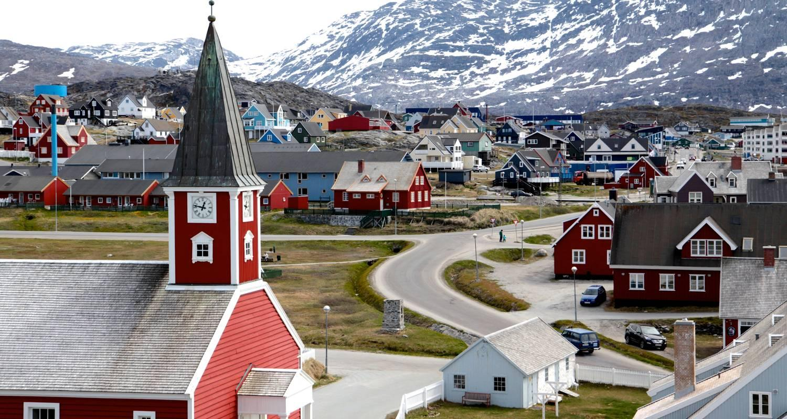

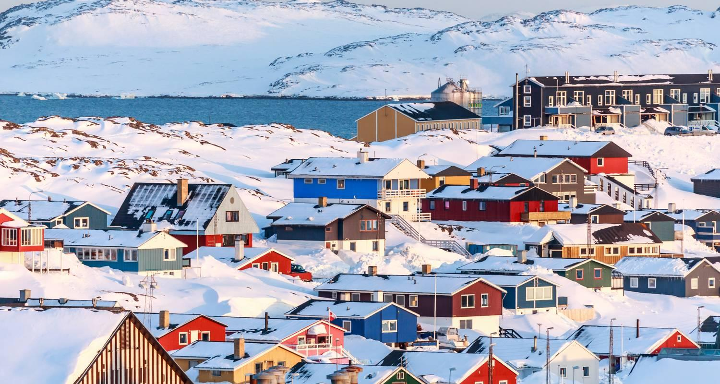

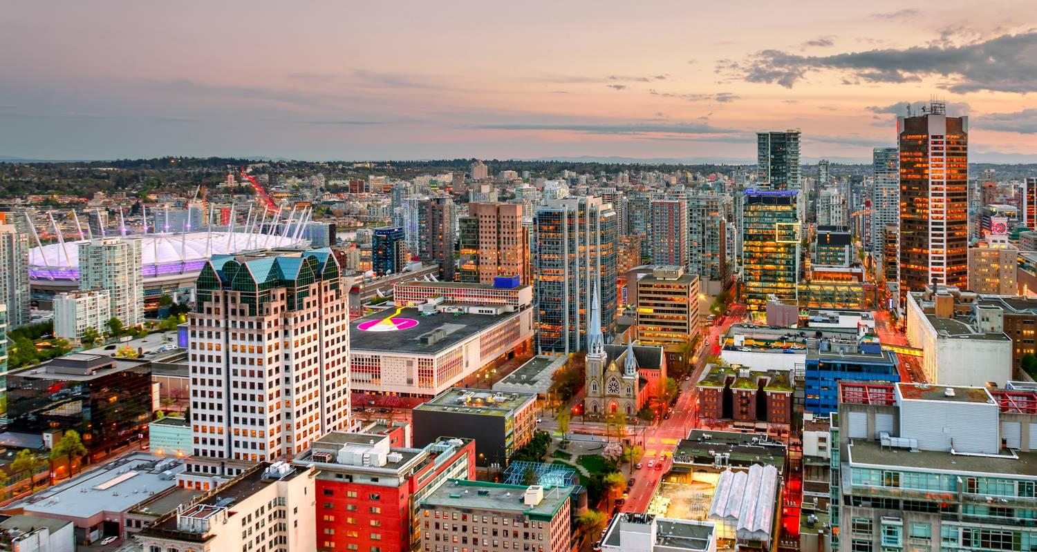

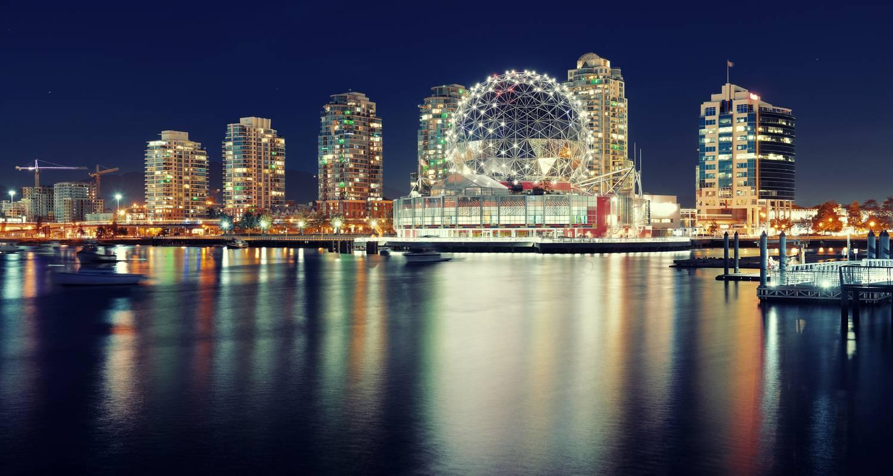

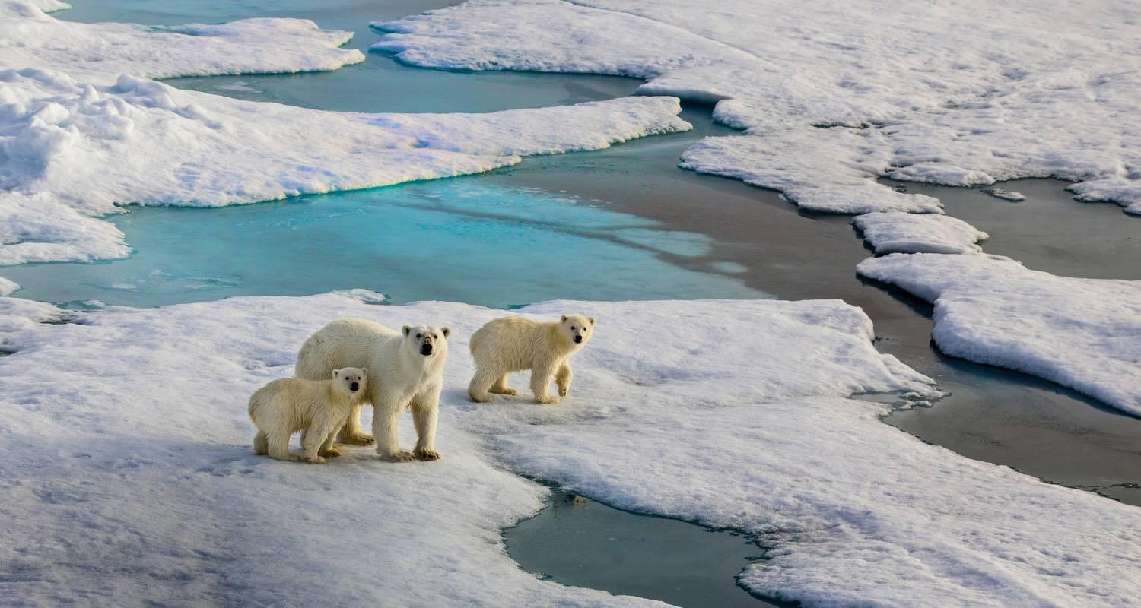

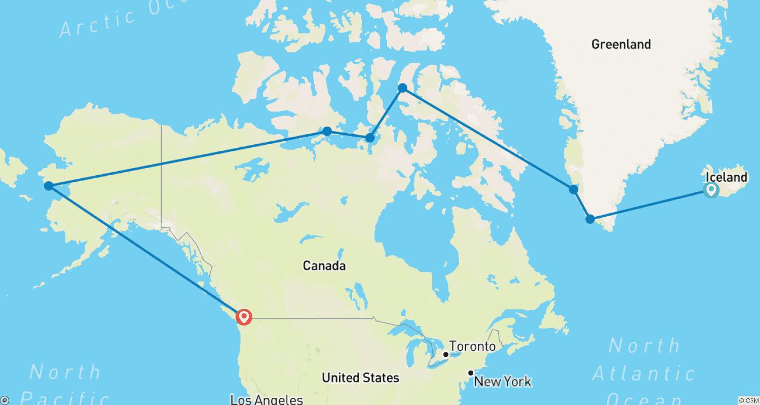

Tour ID: 259217  
Tour Name: 7 Day - Iceland Ring Road & Snæfellsnes Peninsula Small-Group Tour

Tour destinations: ['Reykjavik', 'Thingvellir National Park', 'Geysir', 'Gullfoss', 'Hvolsvollur', 'Seljaland', 'Skogar', 'Skogafoss', 'Reynisfjara', 'Vik', 'Kirkjubaejarklaustur', 'Jokulsarlon', 'Hofn', 'Djupivogur', 'Egilsstadir', 'Dettifoss', 'Mount Namaskard', 'Dimmuborgir', 'Myvatn', 'Skutustadagigar', 'Godafoss', 'Akureyri', 'Blonduos', 'Hvitserkur', 'Laugarbakki', 'Grábrók Volcano', 'Hraunfossar', 'Reykholt', 'Borgarnes', 'Kirkjufell Mountain', 'Snaefellsjokull National Park', 'Djupalonssandur', 'Arnarstapi', 'Snæfellsnes']

Tour destinations images:

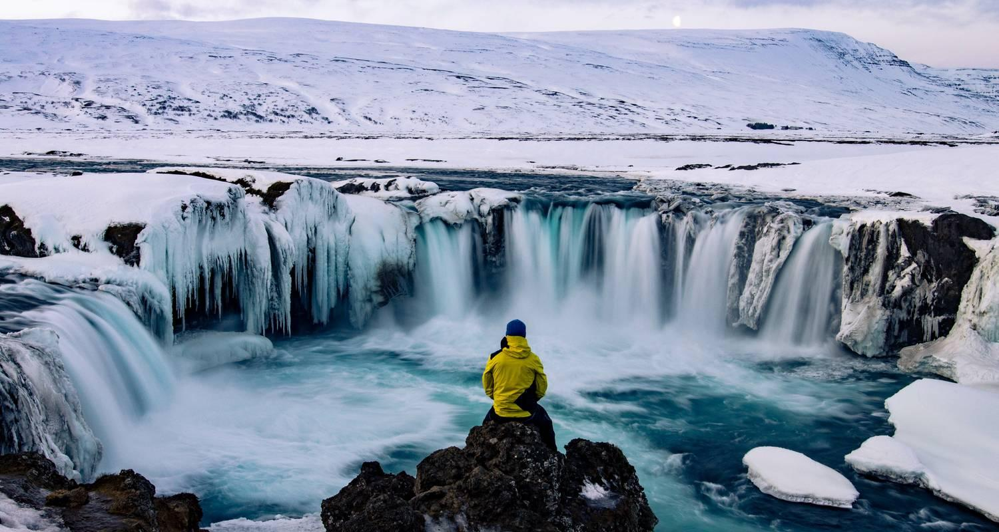

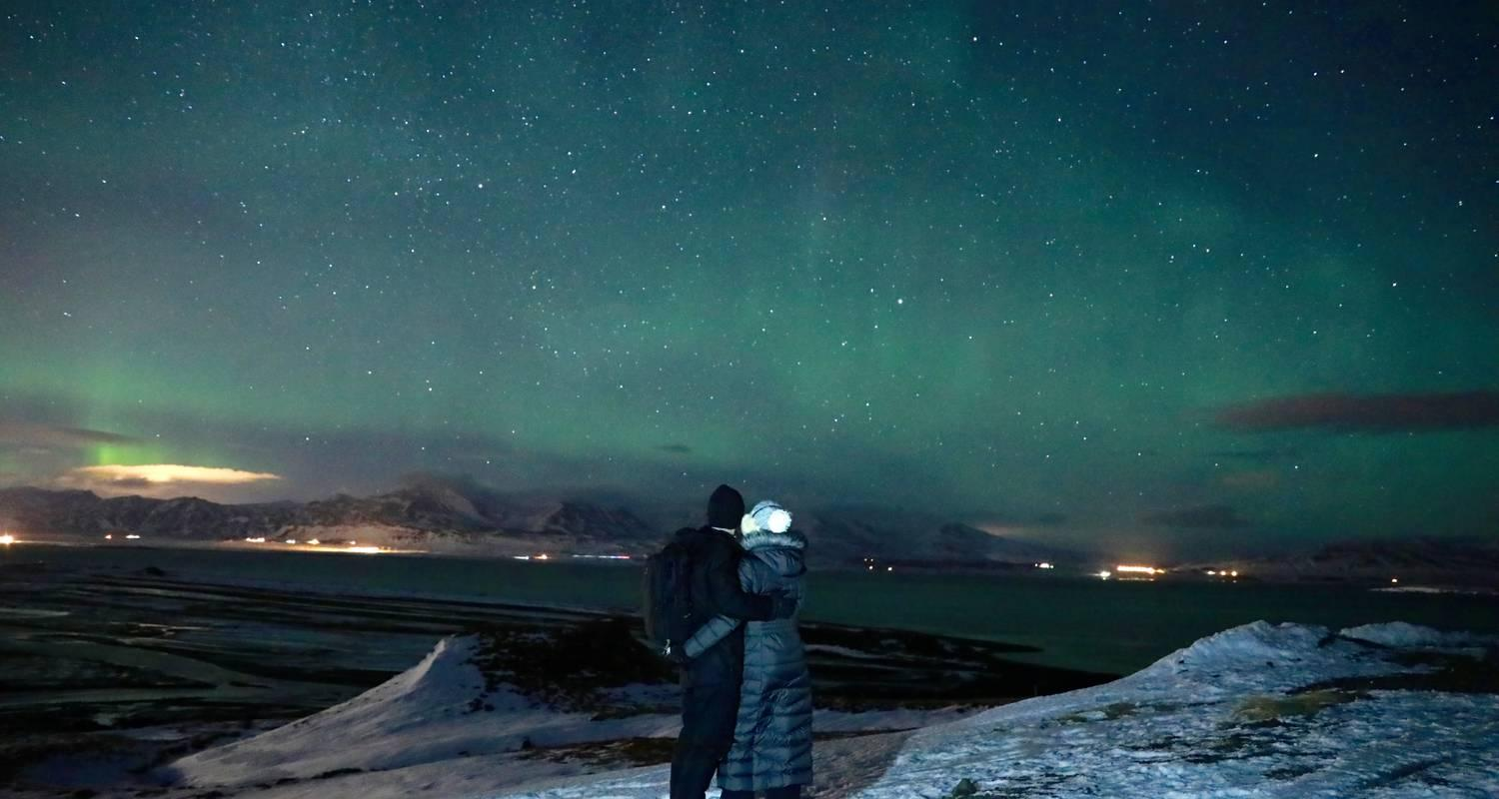

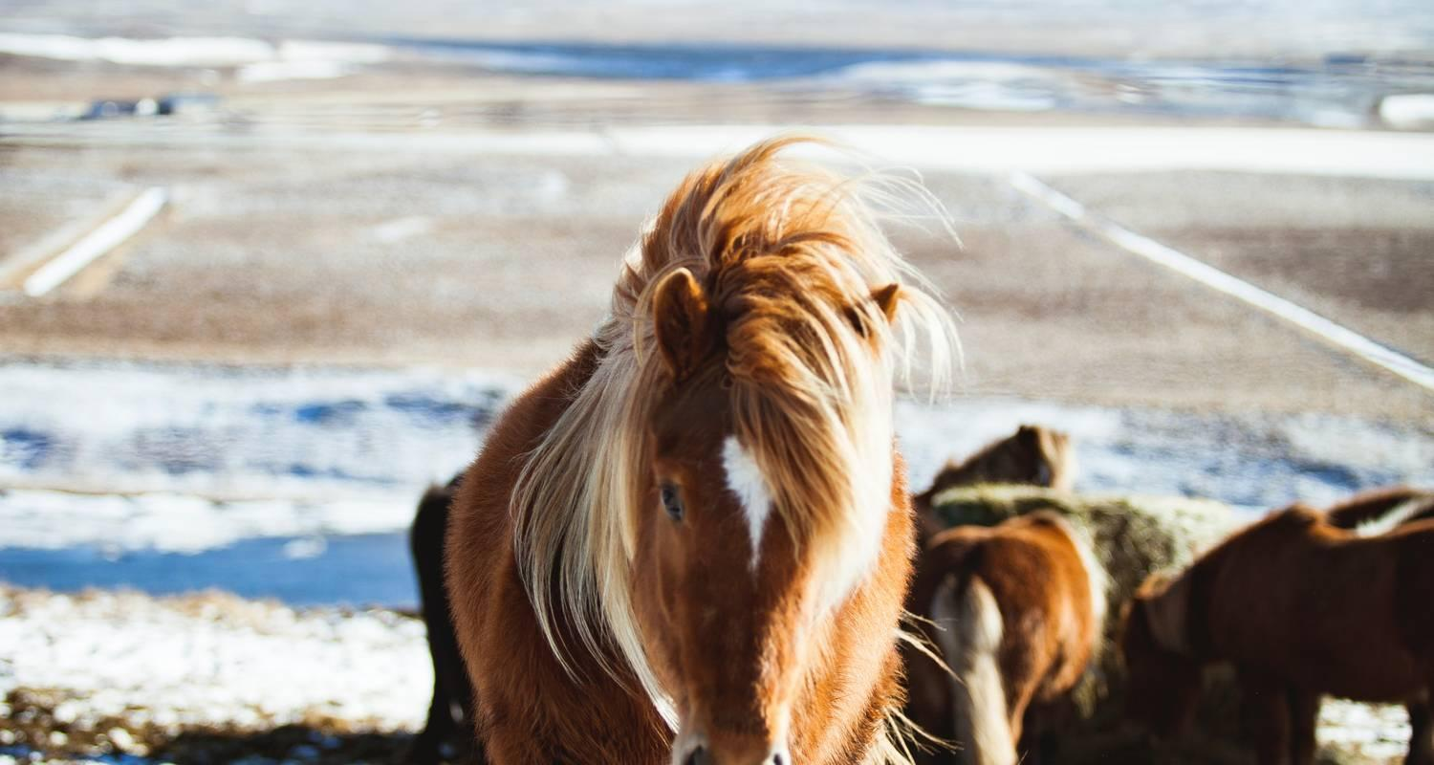

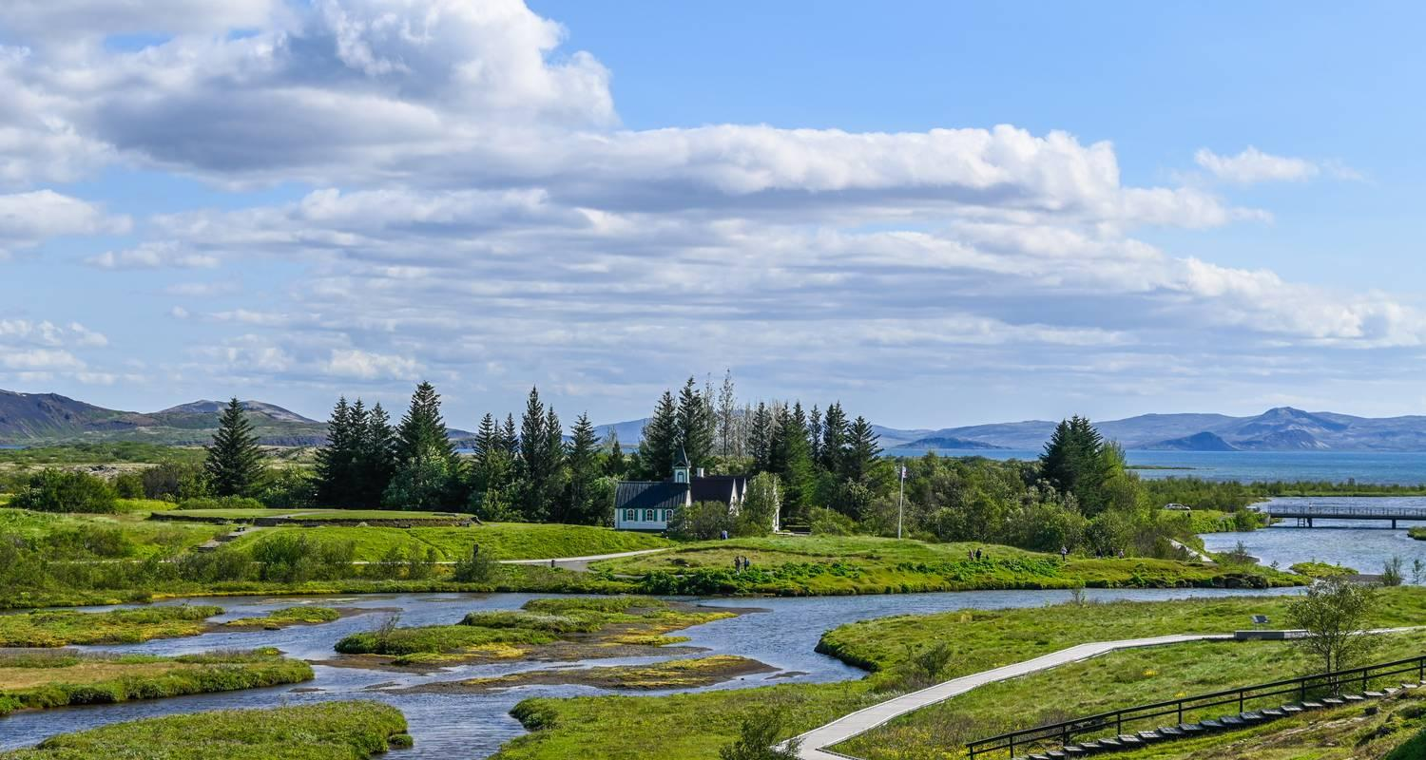

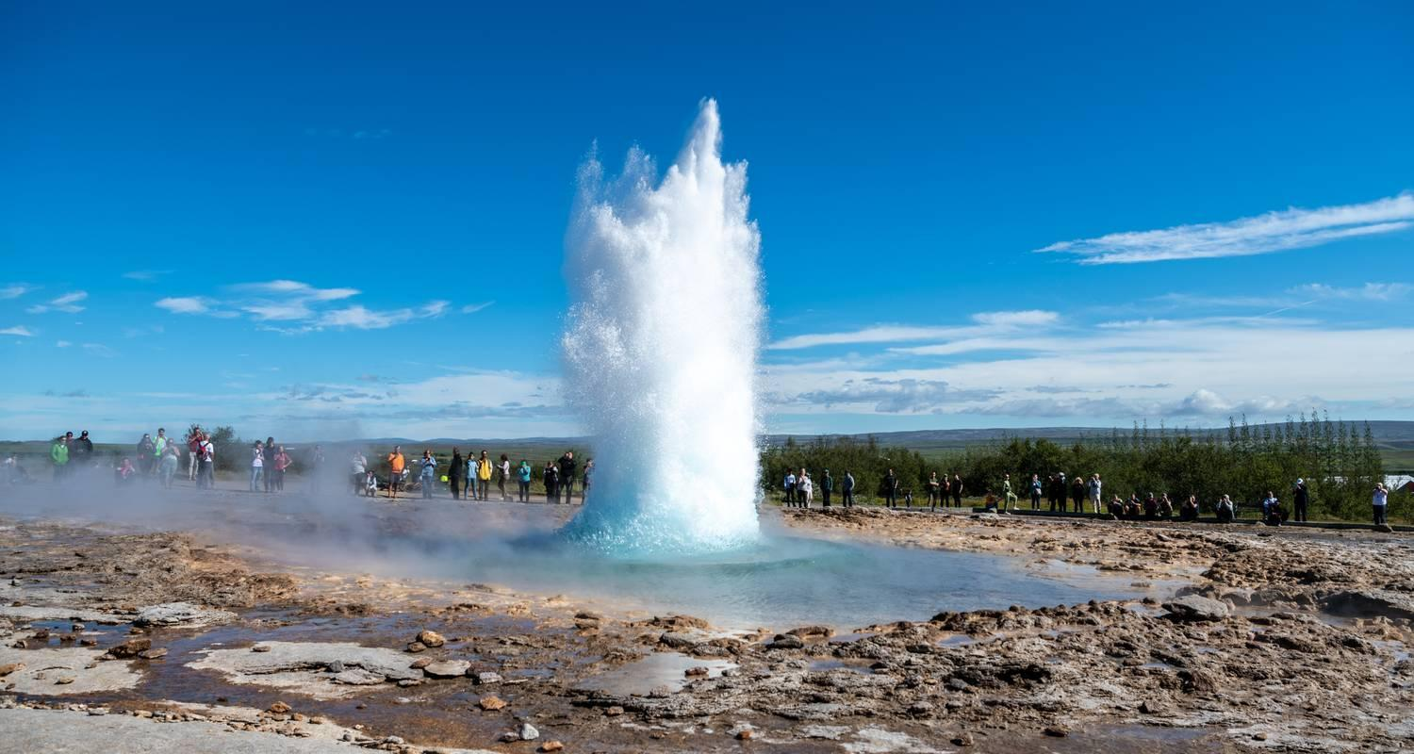

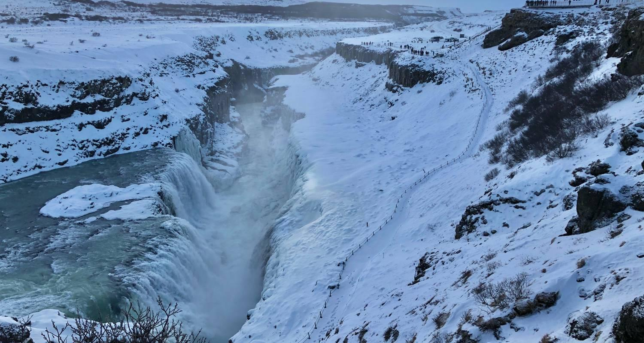

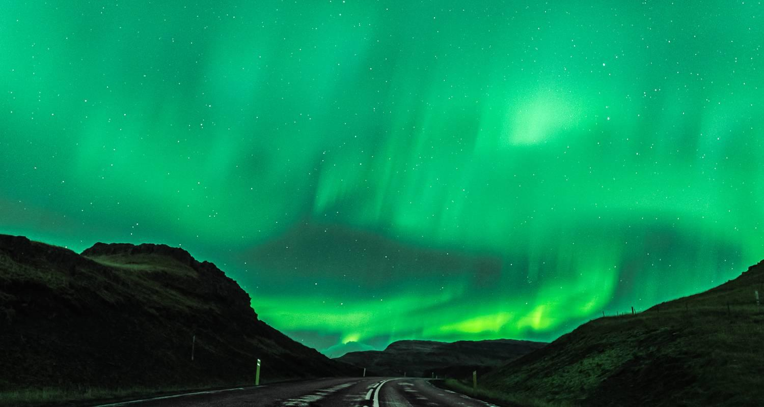

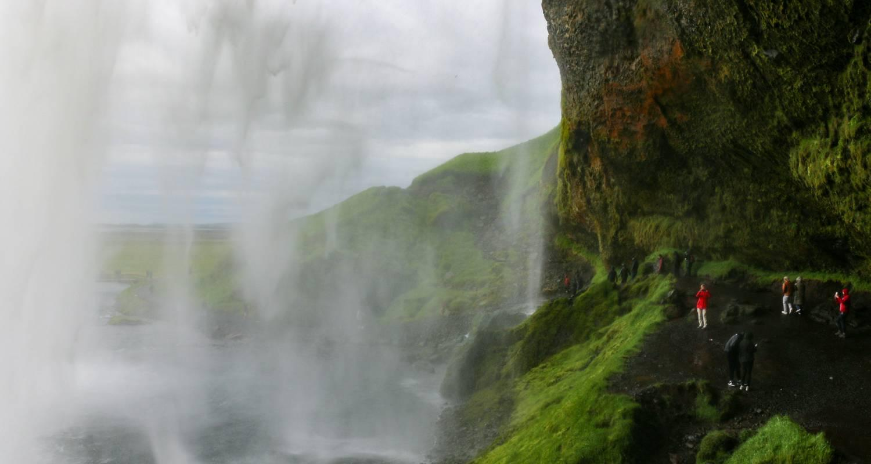

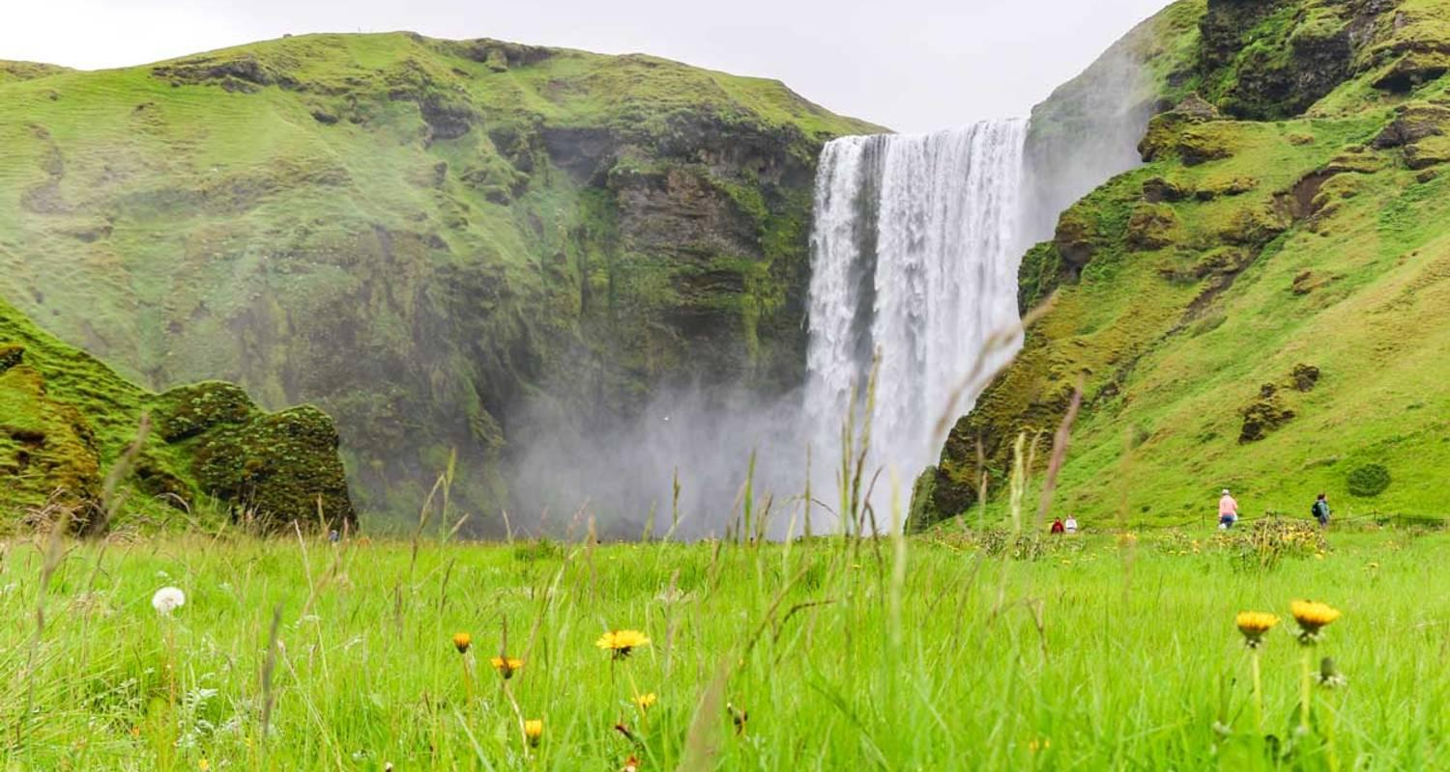

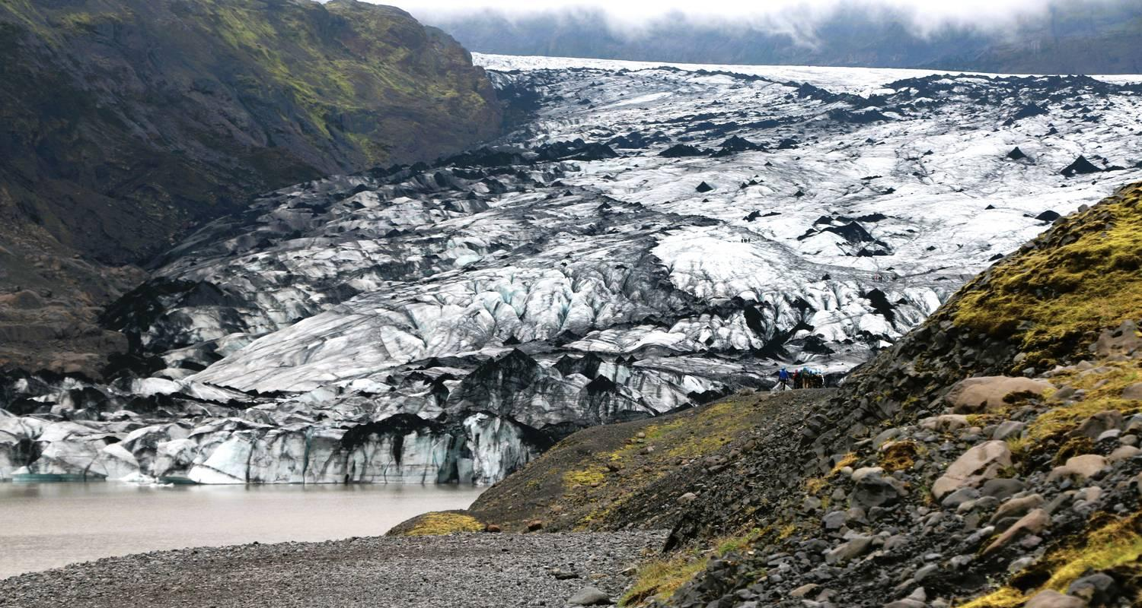

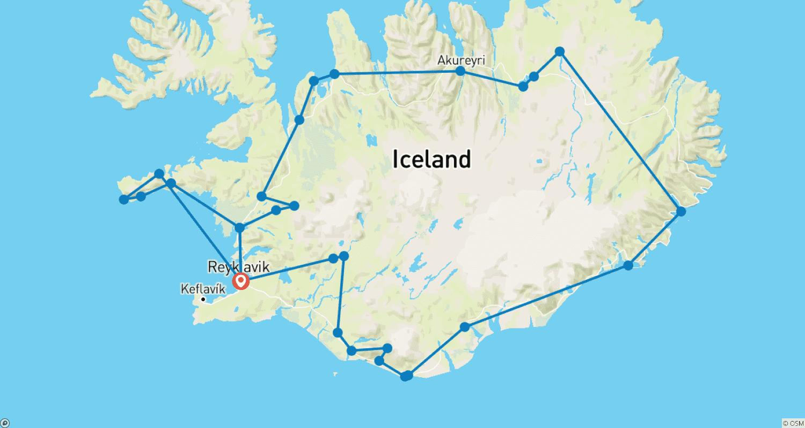

Tour ID: 259636  
Tour Name: Iceland In-Depth

Tour destinations: ['Keflavik', 'Reykjavik', 'Gullfoss', 'Geysir', 'Reynisfjara', 'Kirkjubaejarklaustur', 'Skaftafell', 'Dettifoss', 'Akureyri', 'Husavik', 'Dimmuborgir', 'Hvammstangi', 'Isafjordur', 'Vigur', 'Borgarfjörður', 'Reykholt', 'Hraunfossar']

Tour destinations images:

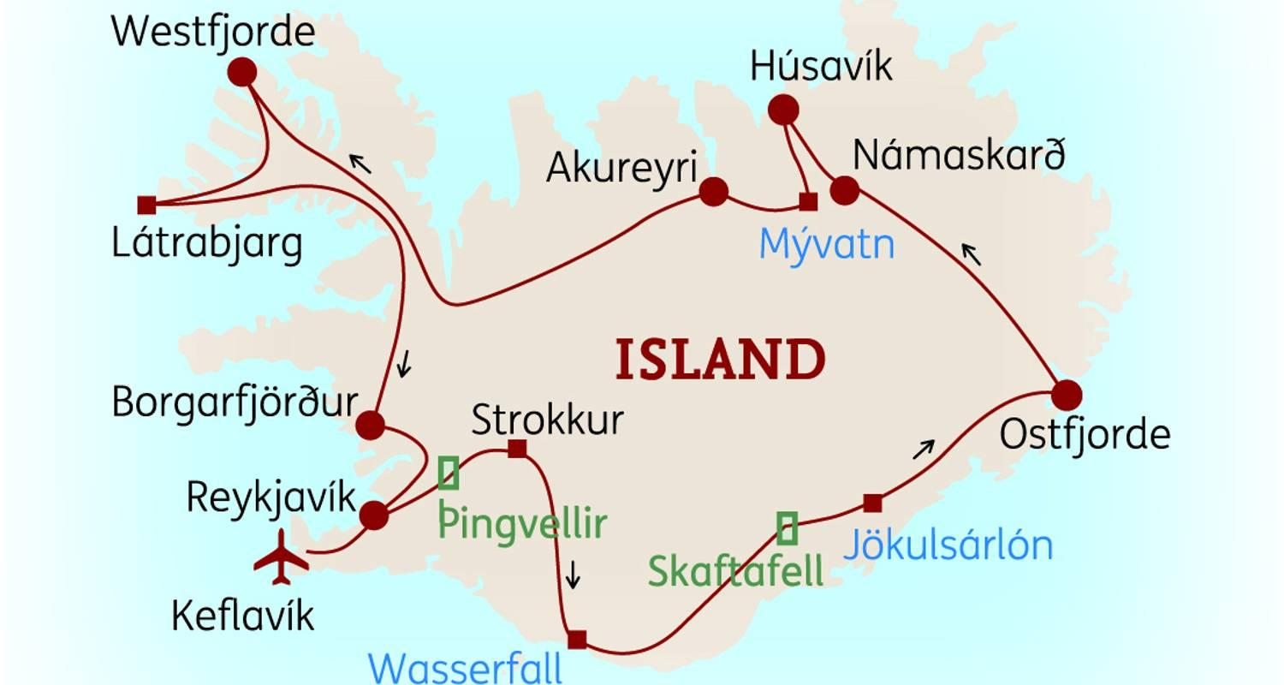

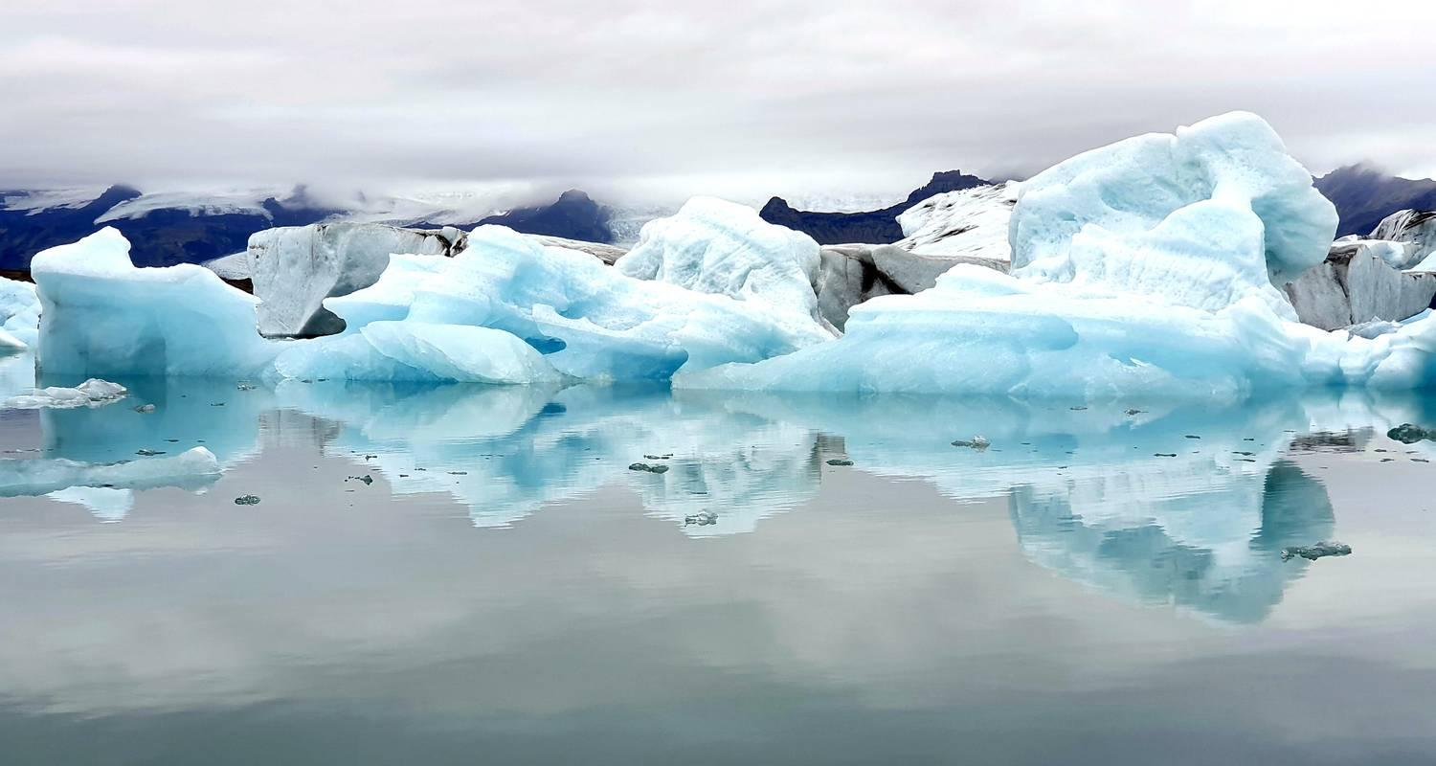

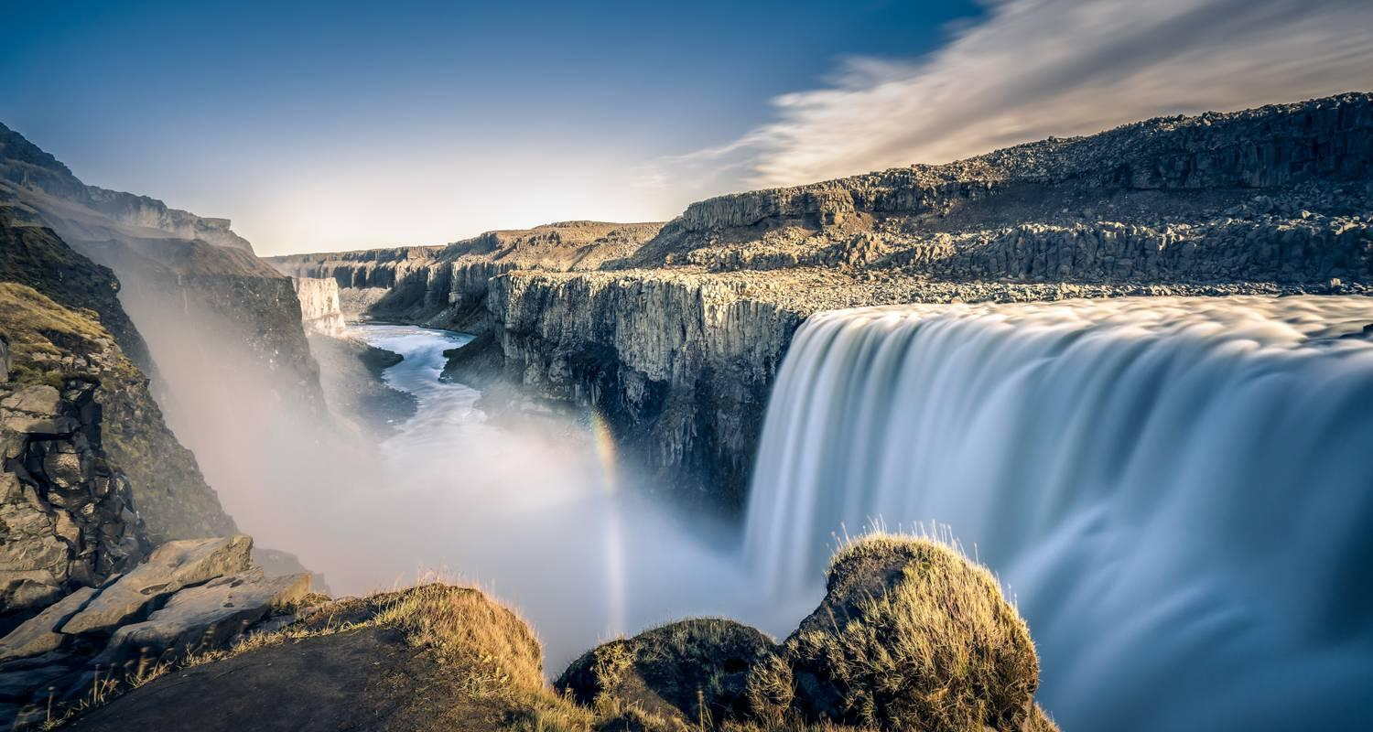

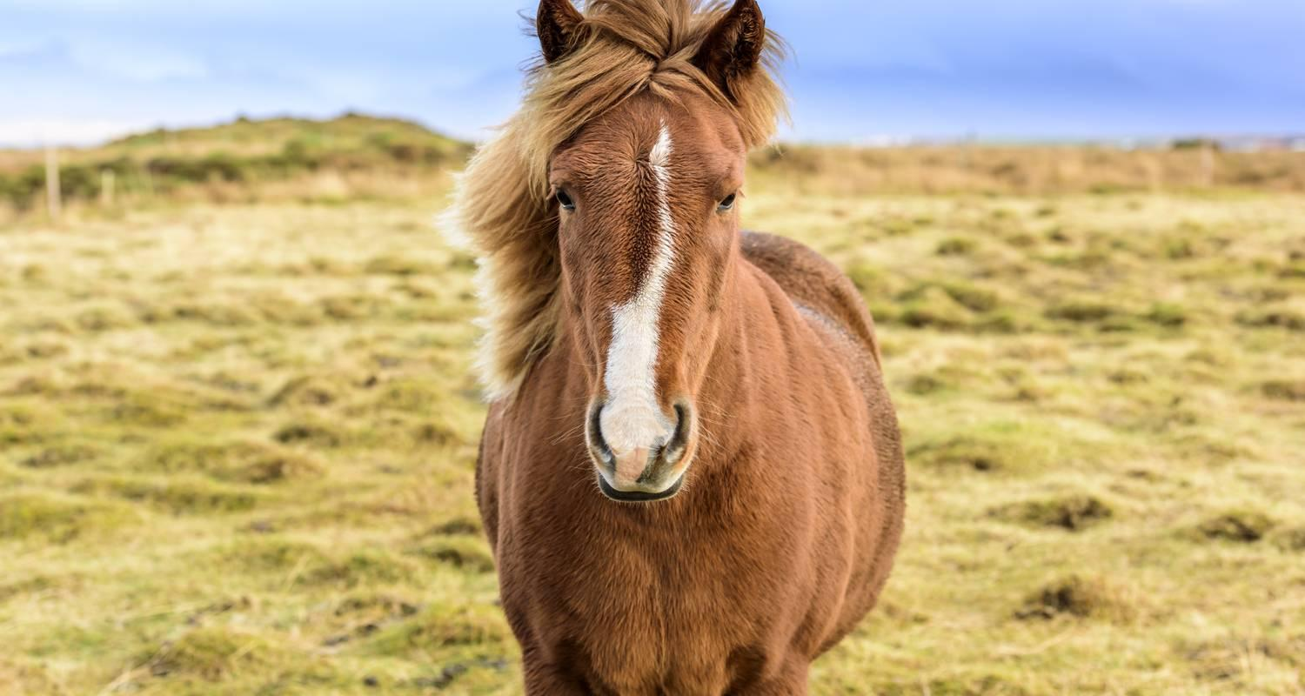

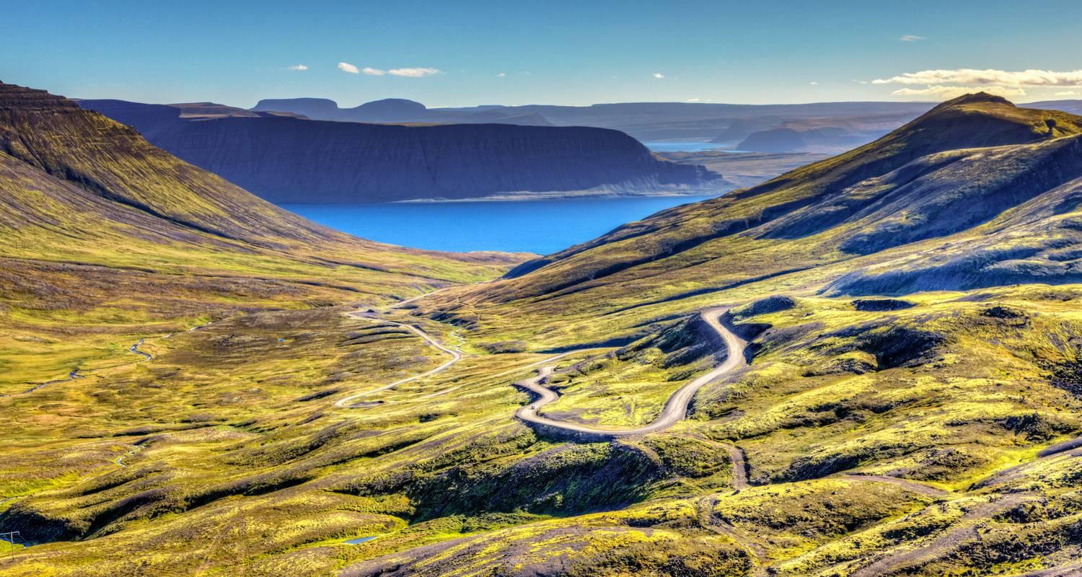

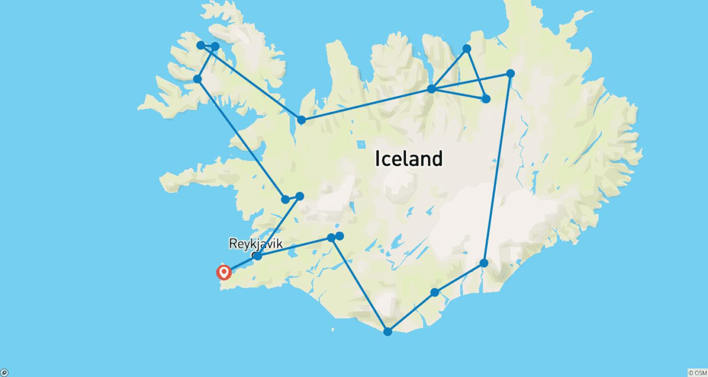

Tour ID: 259637  
Tour Name: Iceland Wintery Impressions

Tour destinations: ['Keflavik', 'Reykjavik', 'Skogafoss', 'Vik', 'Thingvellir National Park', 'Gullfoss']

Tour destinations images:

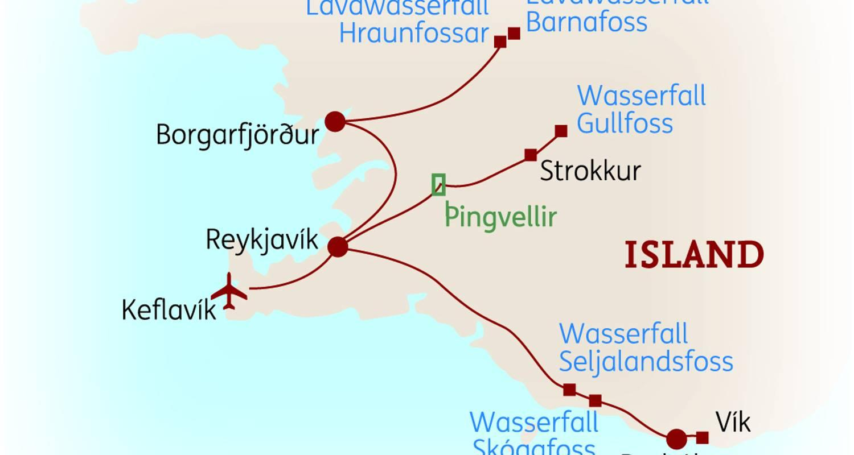

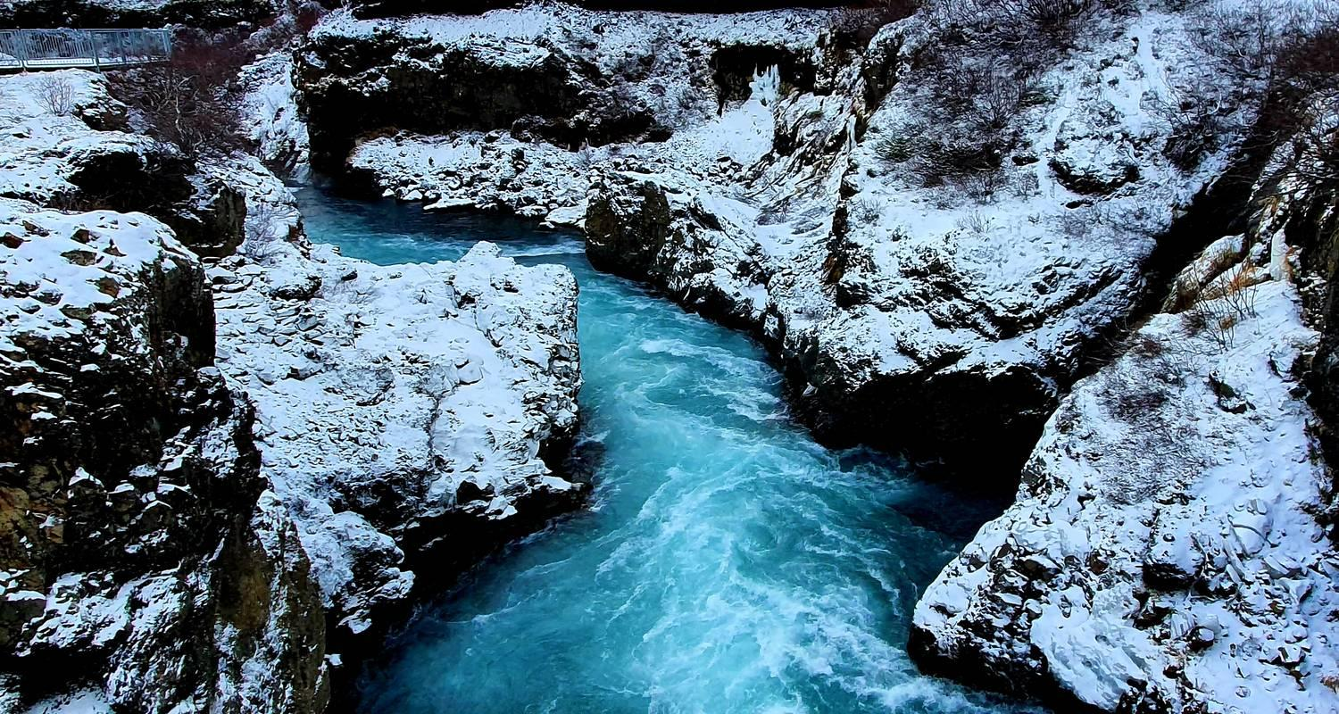

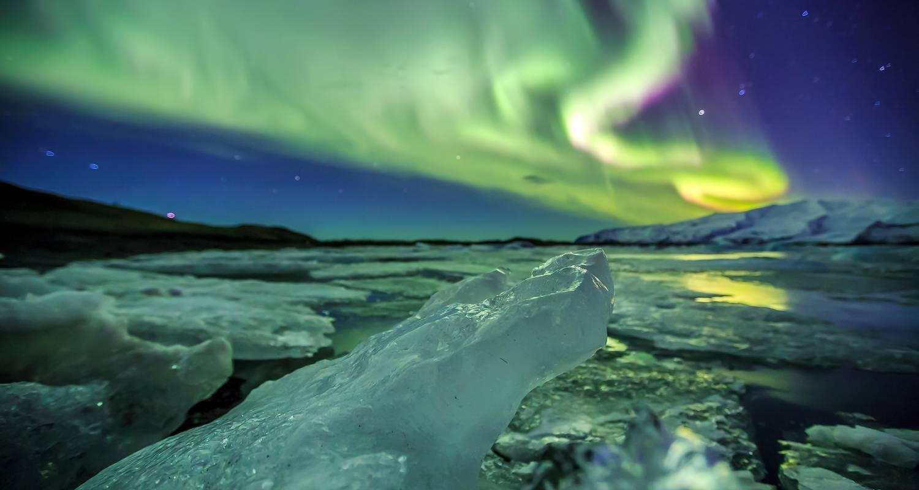

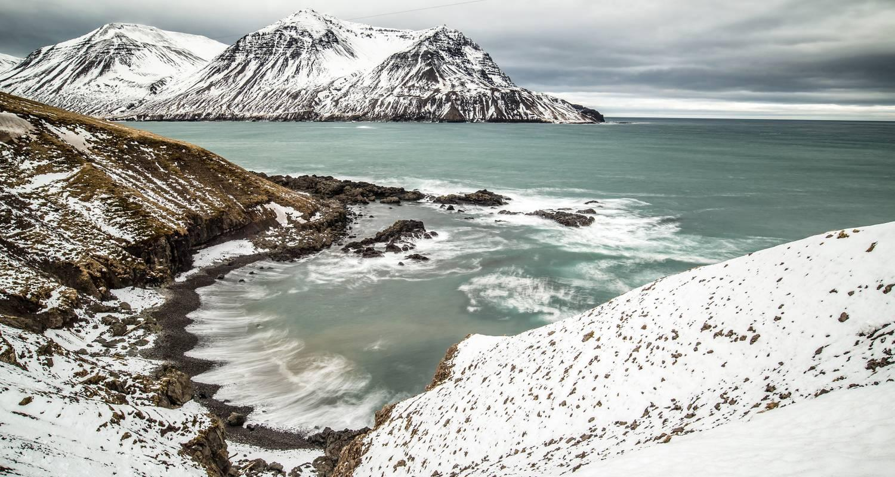

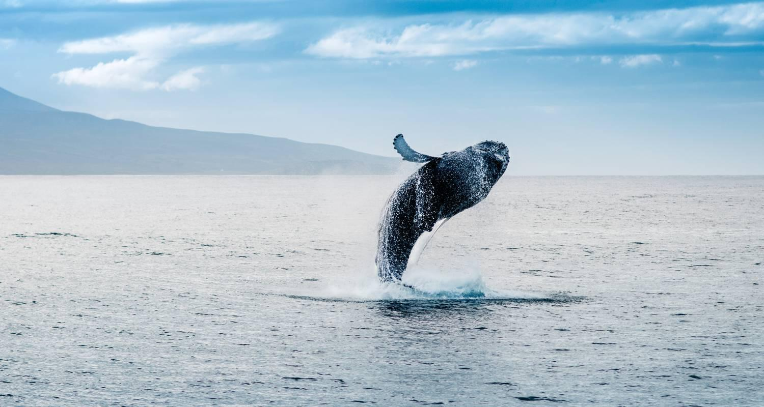

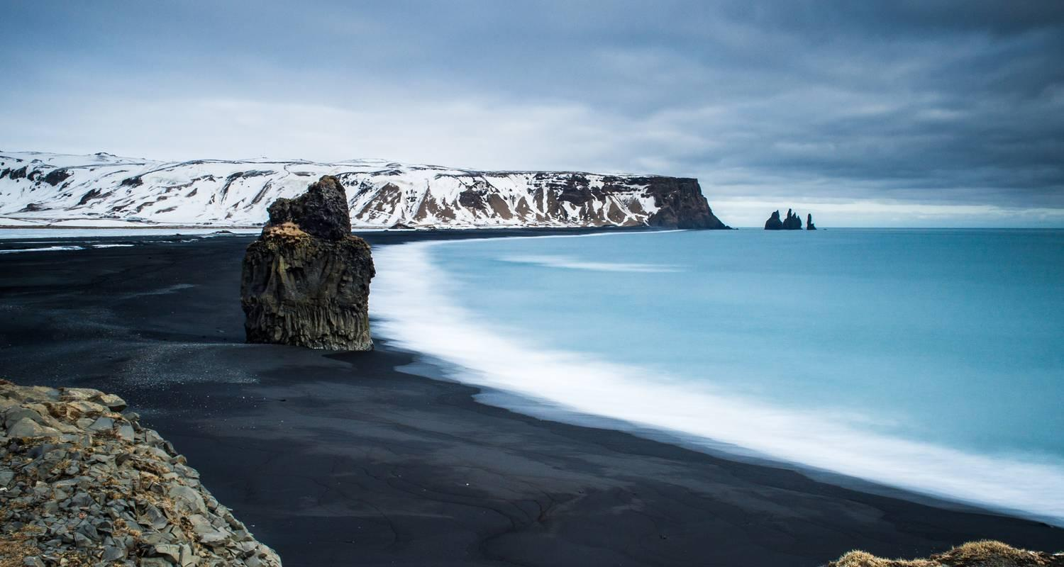

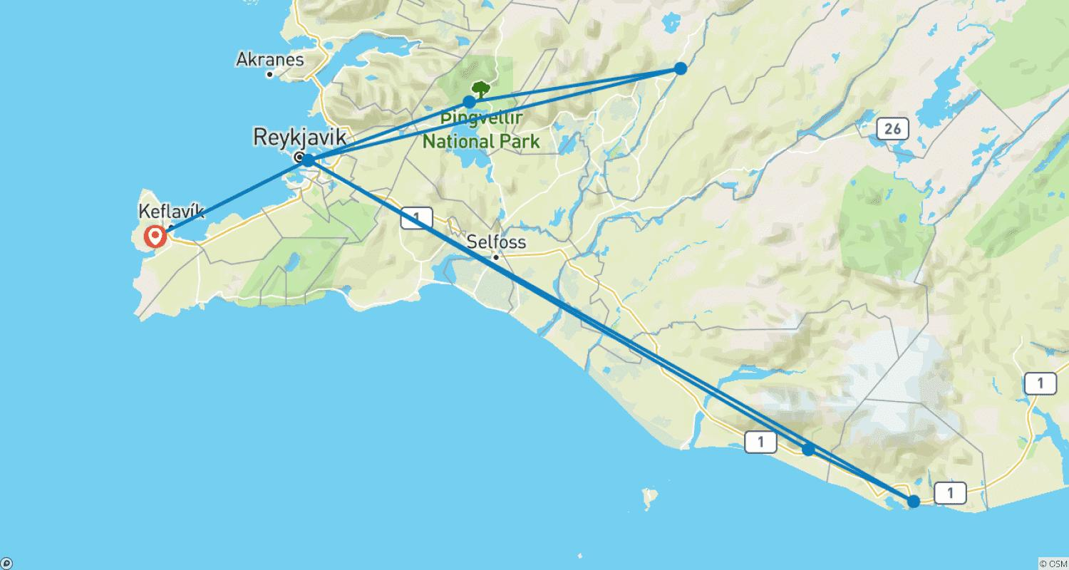

Tour ID: 259639  
Tour Name: Iceland Hiking

Tour destinations: ['Keflavik', 'Reykjavik', 'Snæfellsnes', 'Borgarnes', 'Borgarfjörður', 'Laugarbakki', 'Akureyri', 'Godafoss', 'Dettifoss', 'Myvatn', 'Egilsstadir', 'Hvolsvollur', 'Gullfoss', 'Thingvellir National Park']

Tour destinations images:

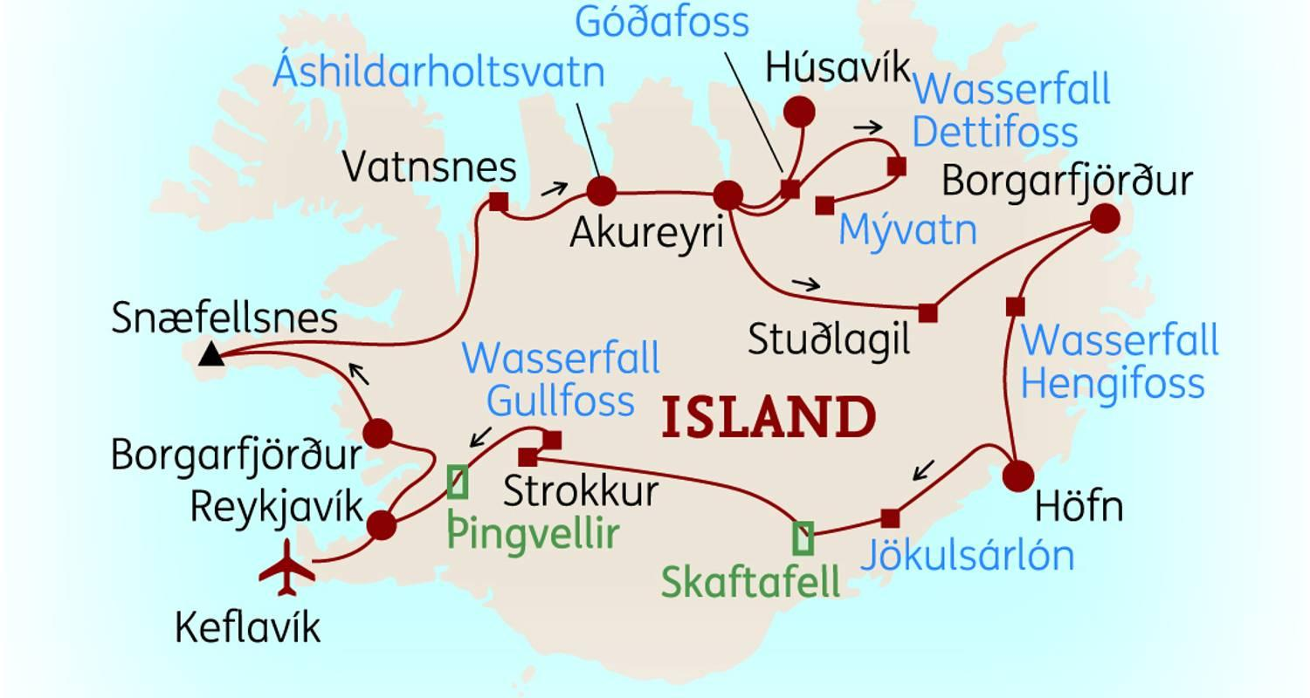

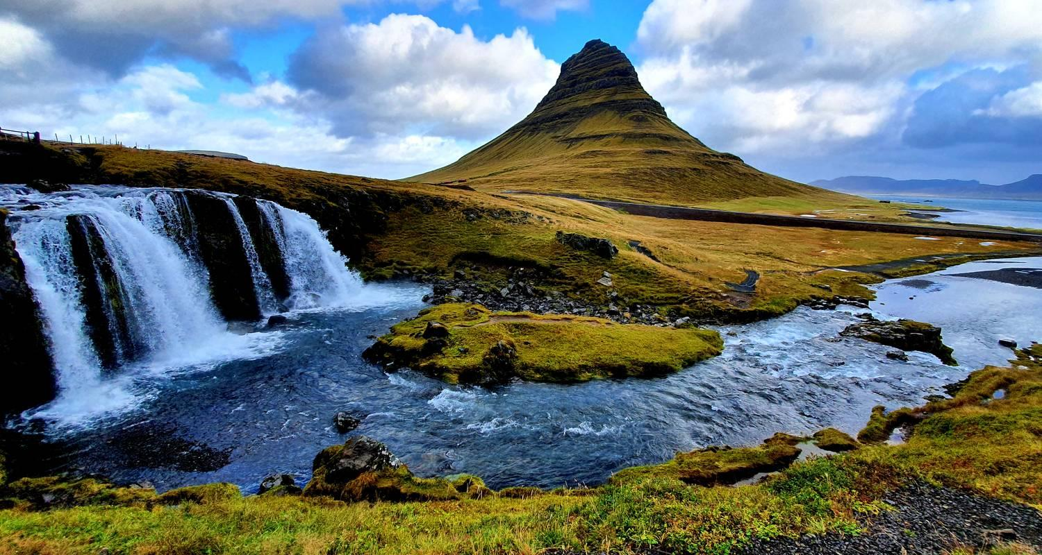

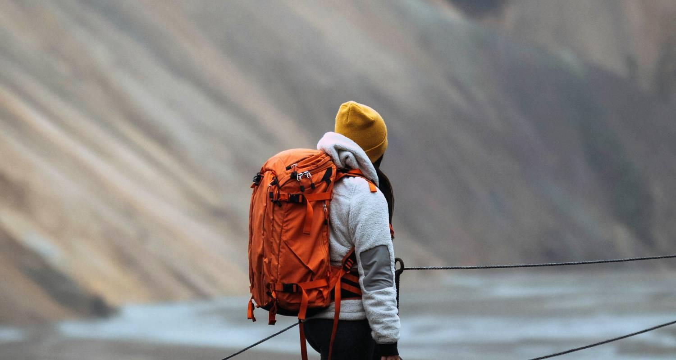

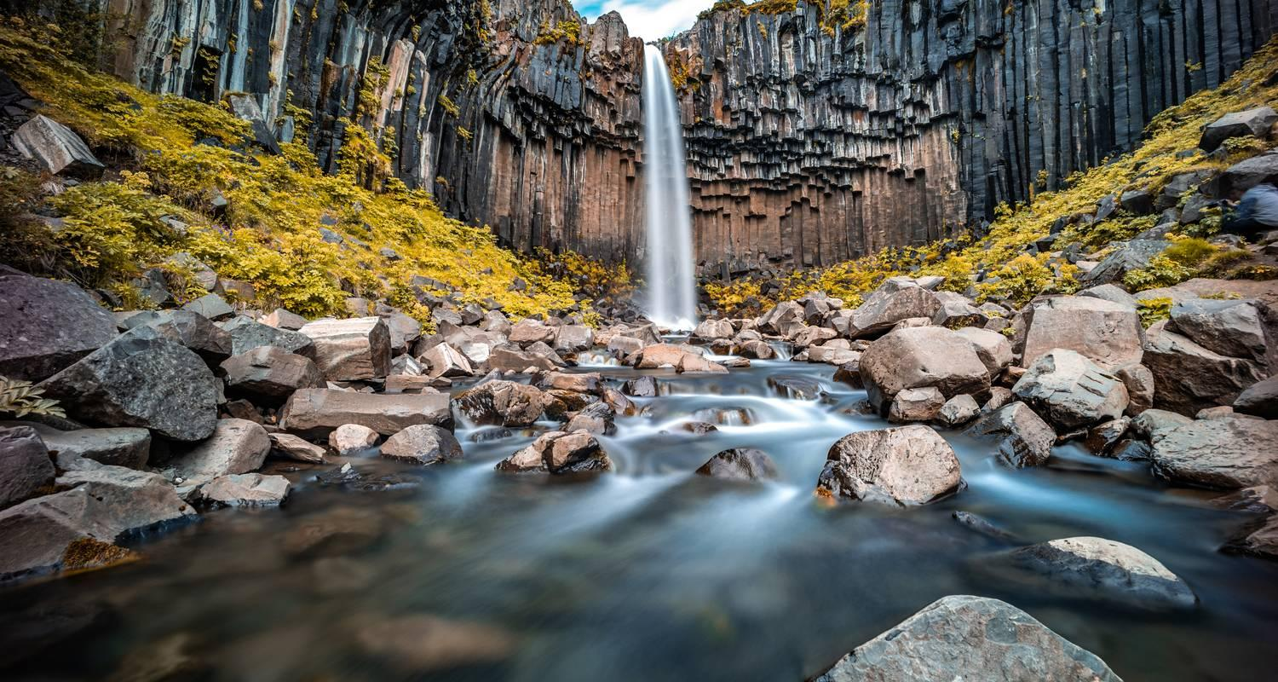

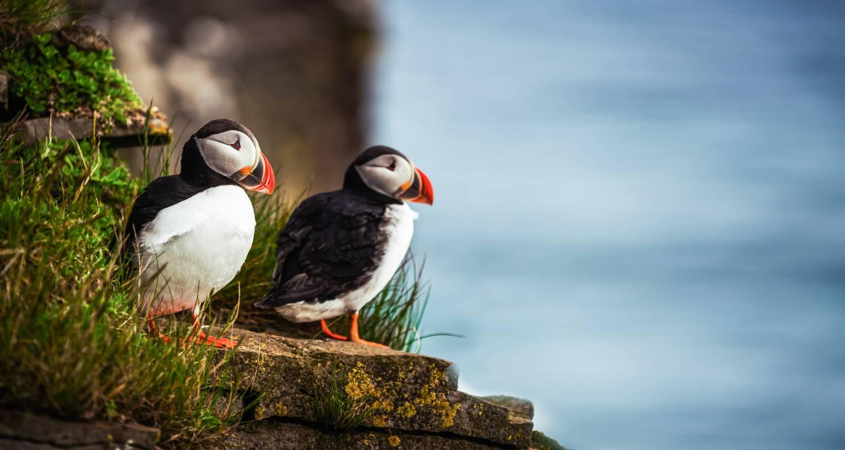

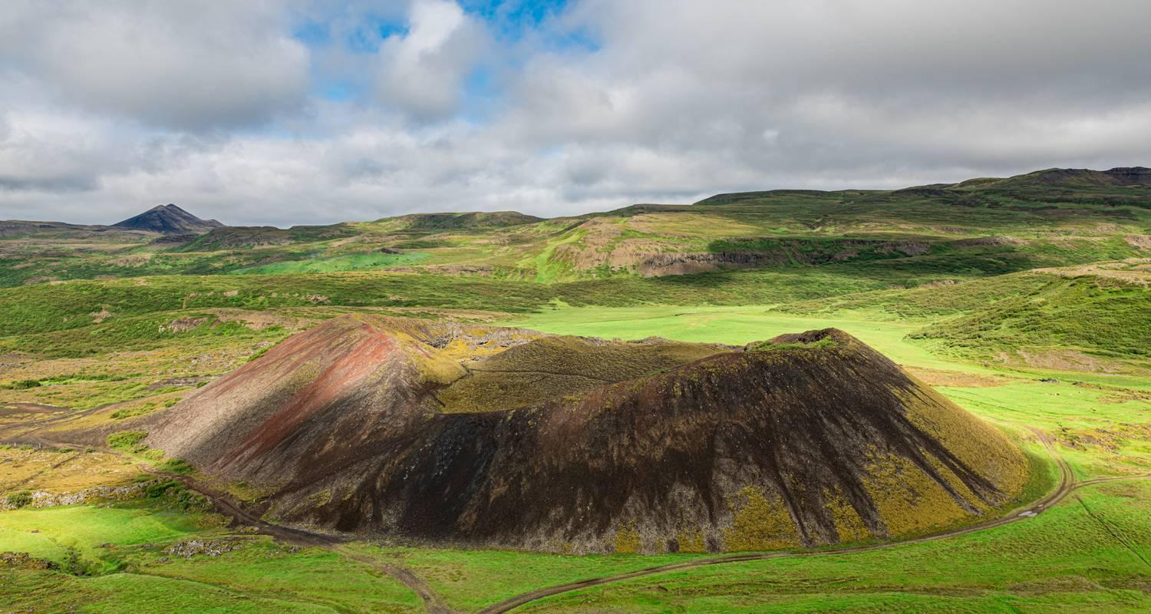

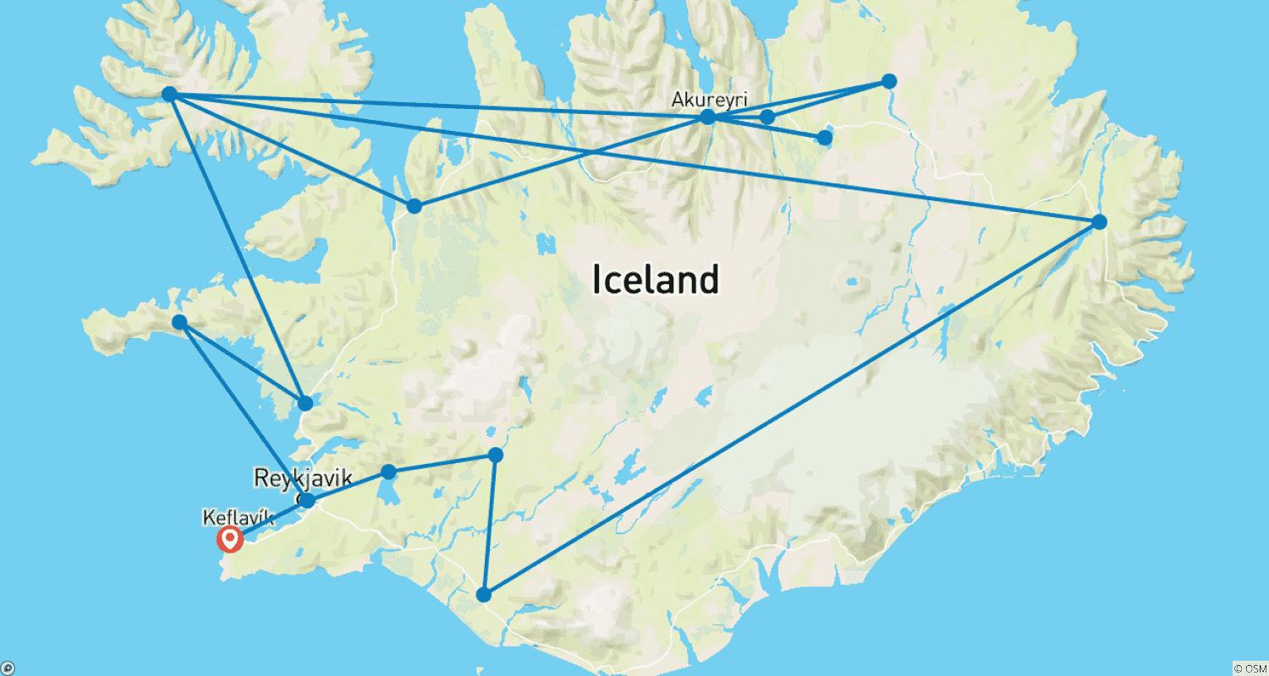

Tour ID: 259948  
Tour Name: Great Explorer Trail | Iceland, Greenland & the Northwest Passage

Tour destinations: ['Reykjavik', 'Ittoqqortoormiit', 'Sermersooq', 'Nuuk', 'Sisimiut', 'Ilulissat', 'Cambridge Bay', 'Montreal']

Tour destinations images:





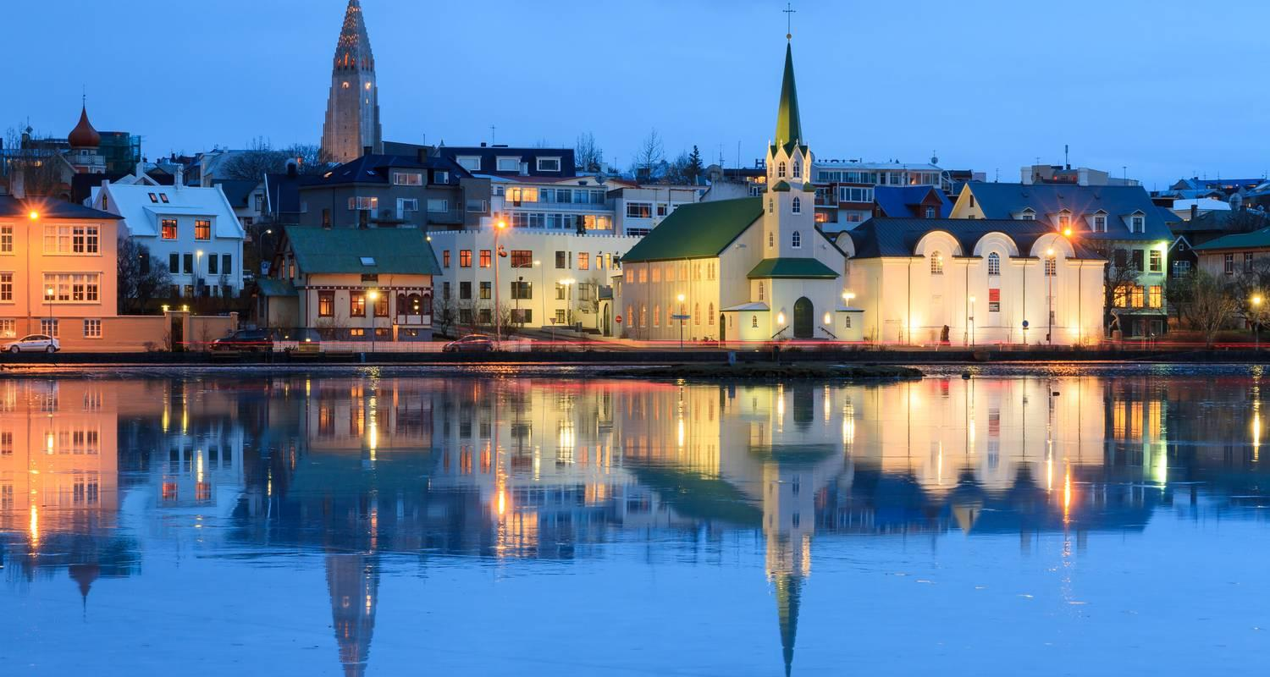





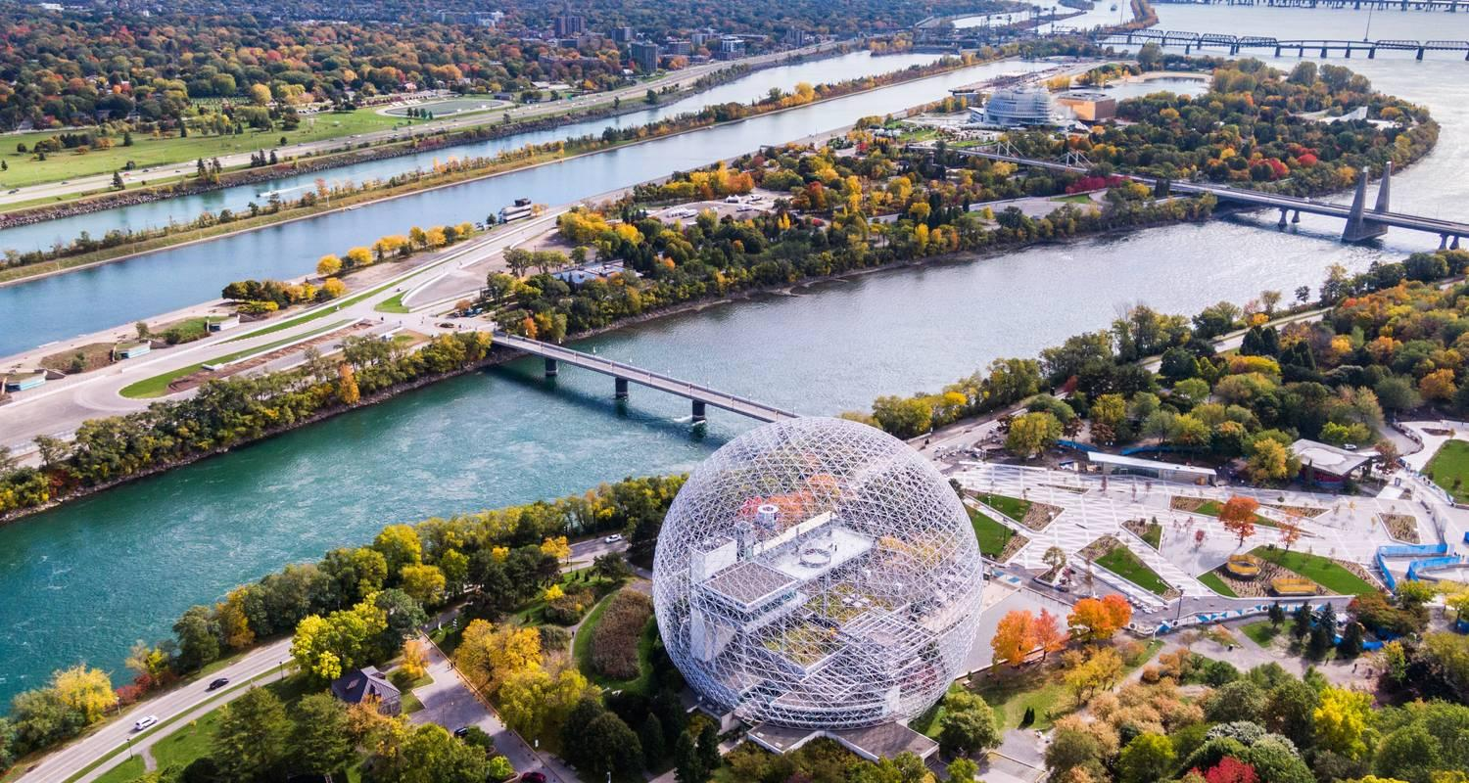

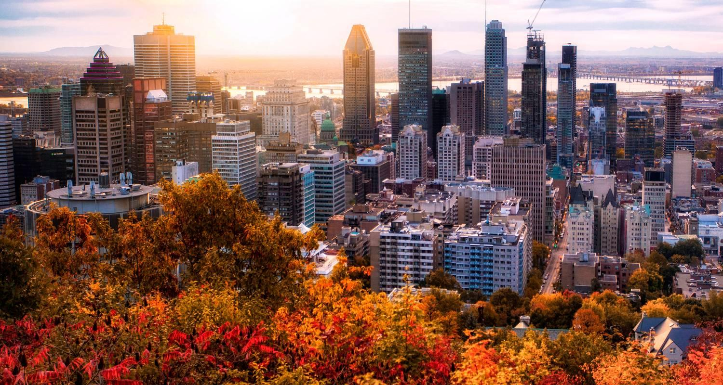

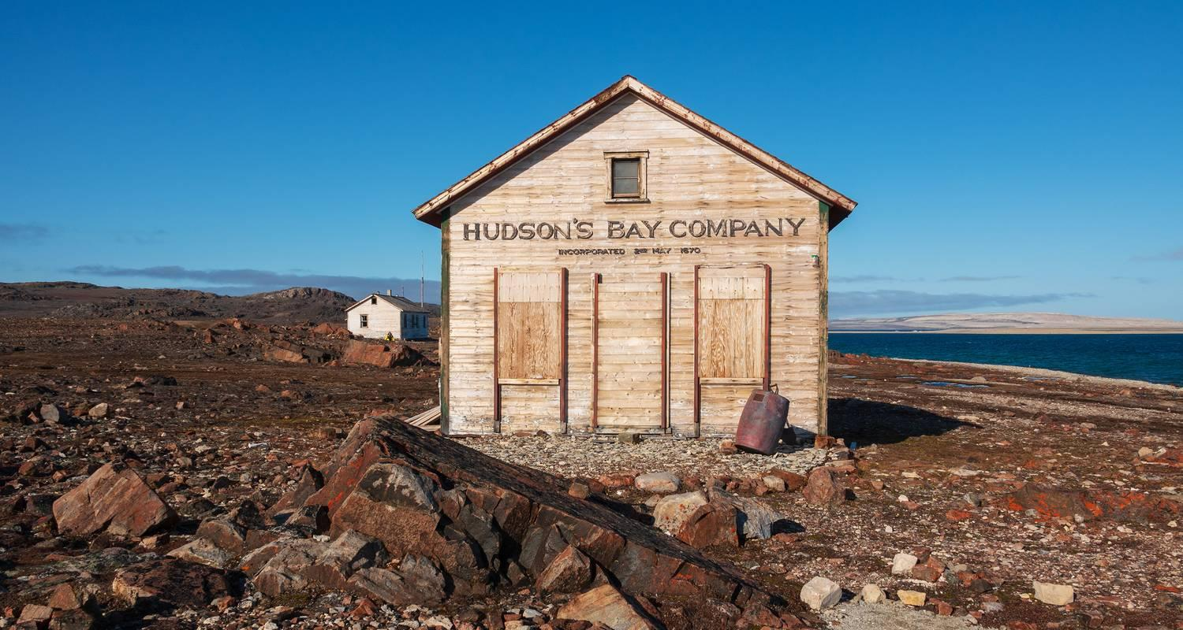

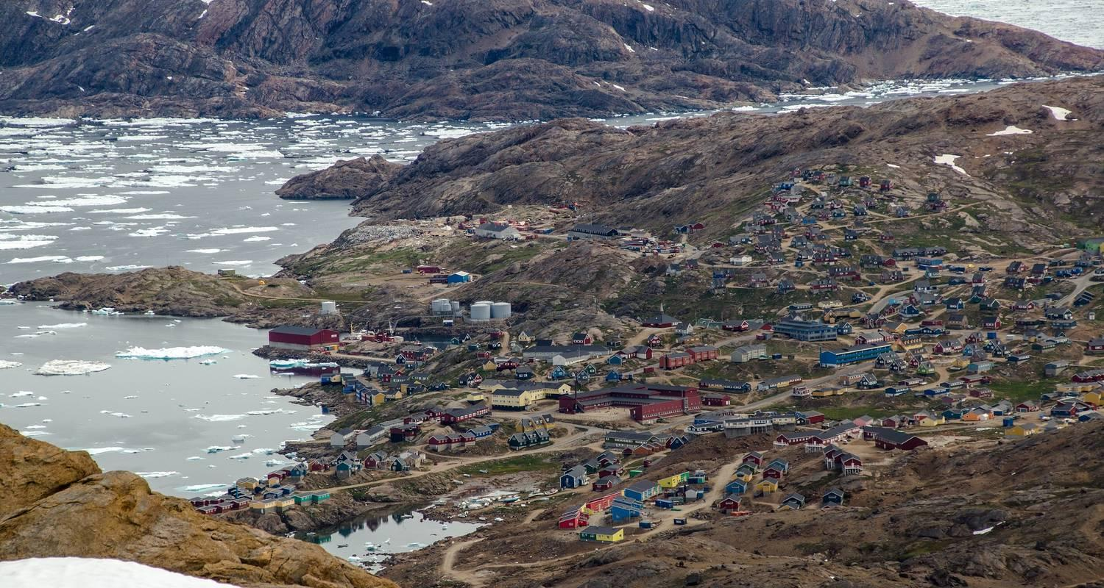

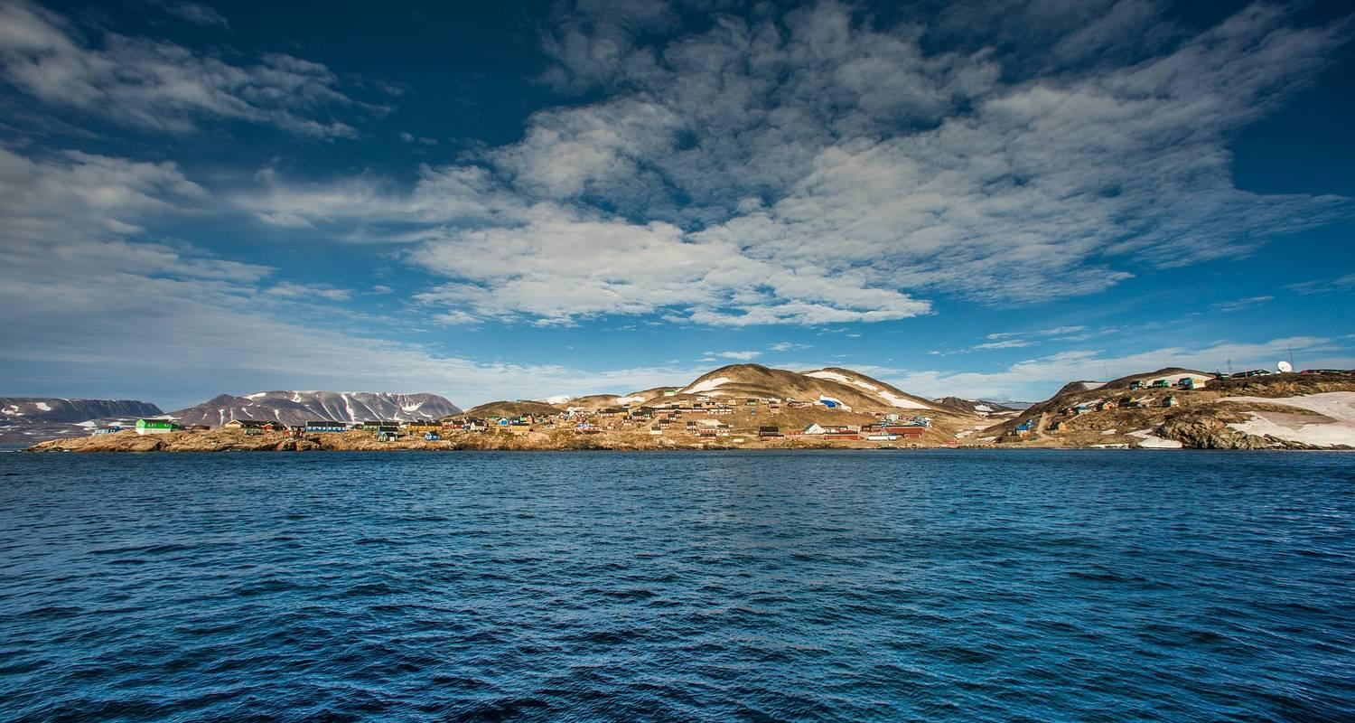

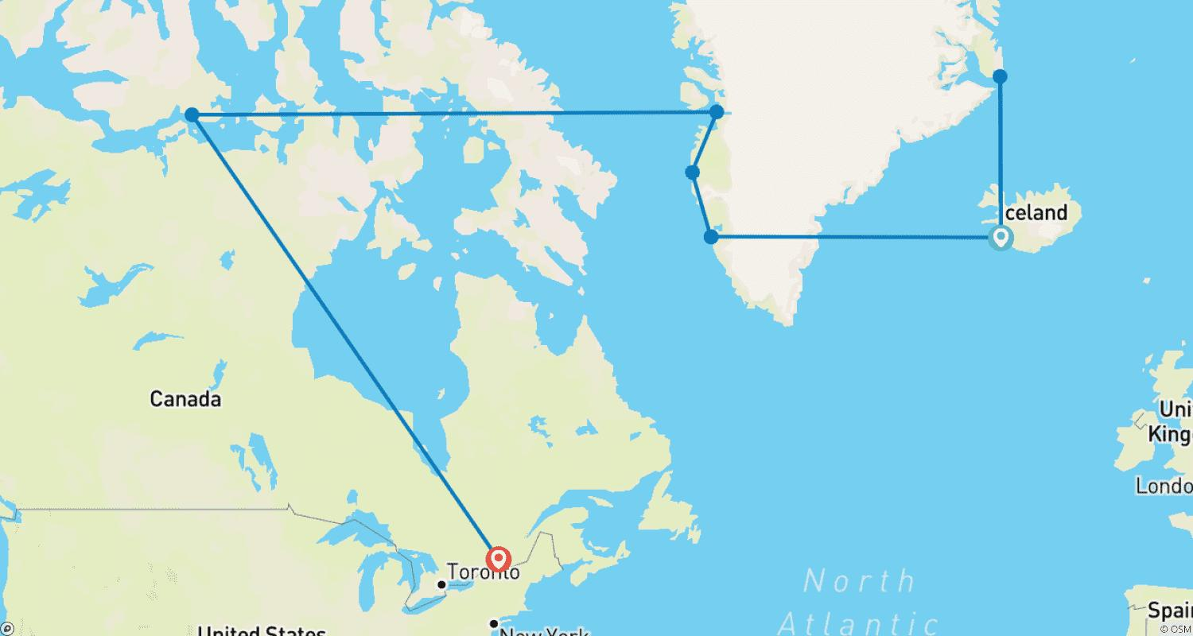

Tour ID: 259951  
Tour Name: Reykjavík to Cambridge Bay

Tour destinations: ['Reykjavik', 'Blue Lagoon']

Tour destinations images:

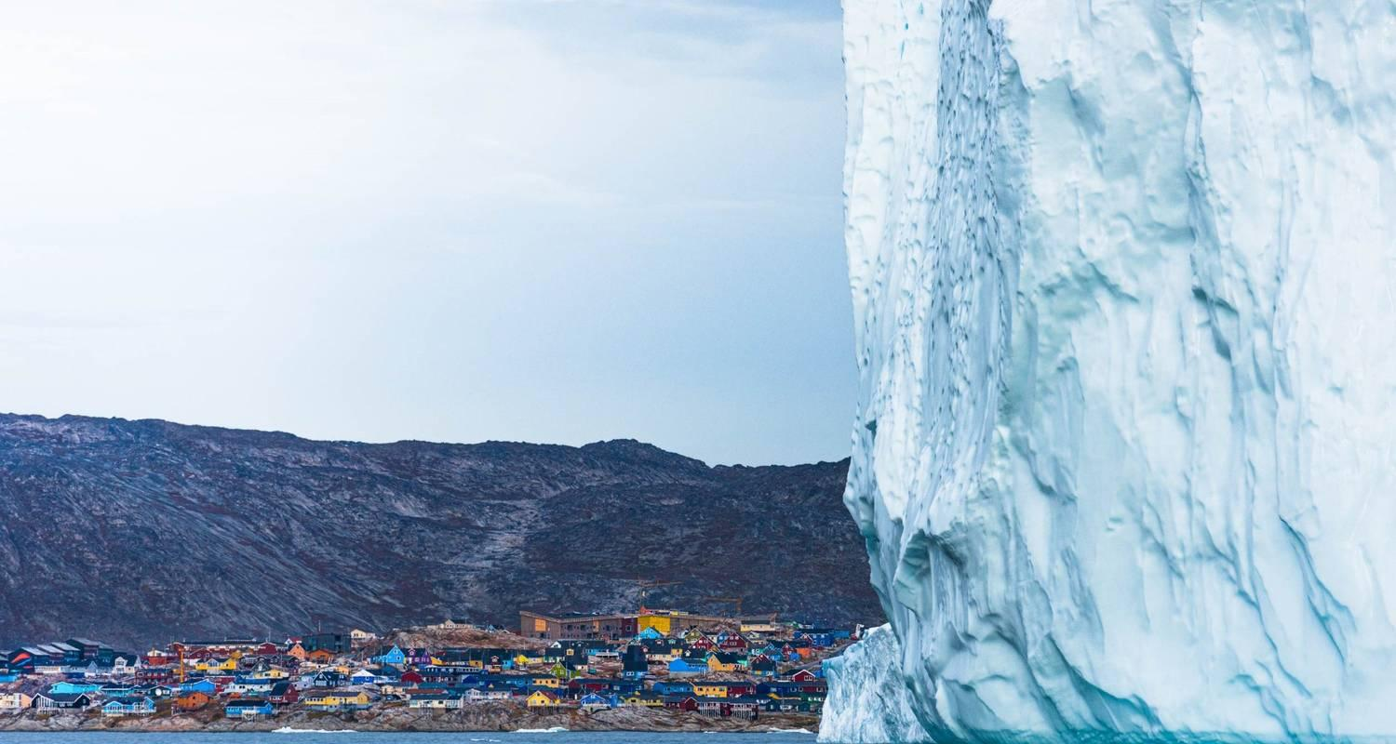

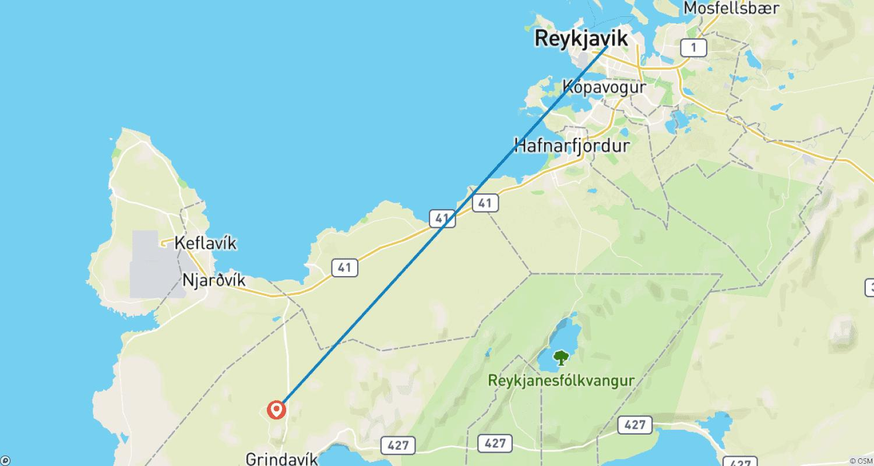

Tour ID: 260051  
Tour Name: Kayak and Ice Trekking Expedition 2 weeks (from Iceland)

Tour destinations: ['Reykjavik', 'Narsarsuaq', 'Narsaq']

Tour destinations images:

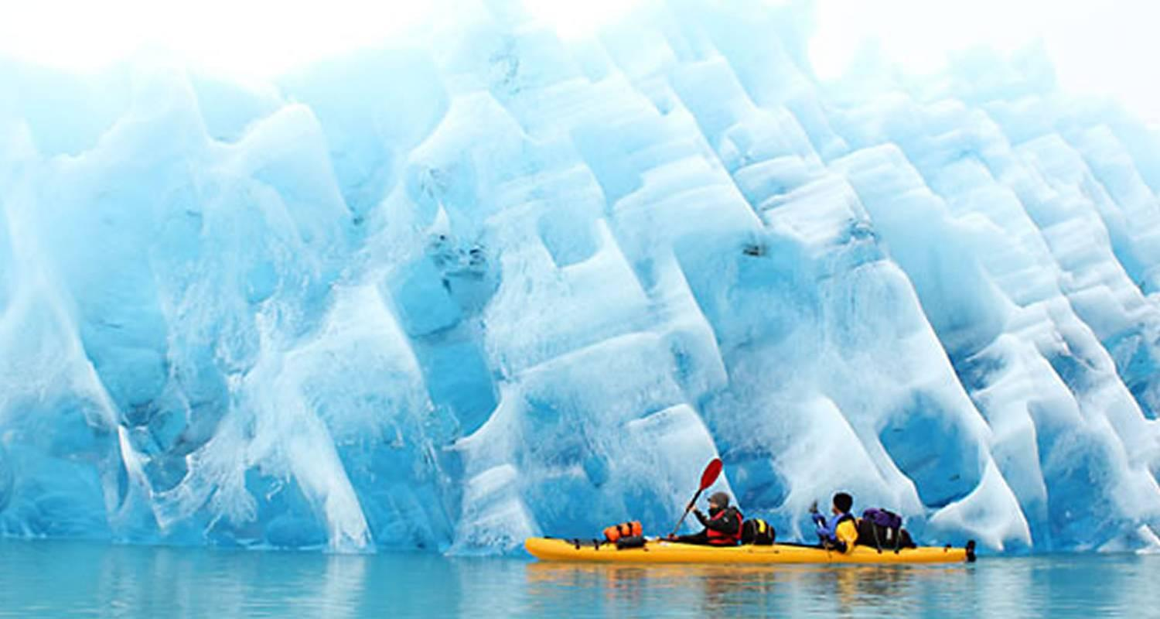

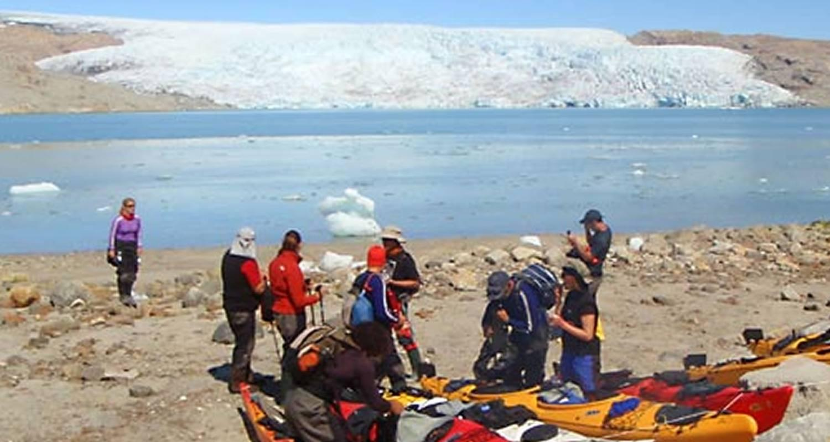

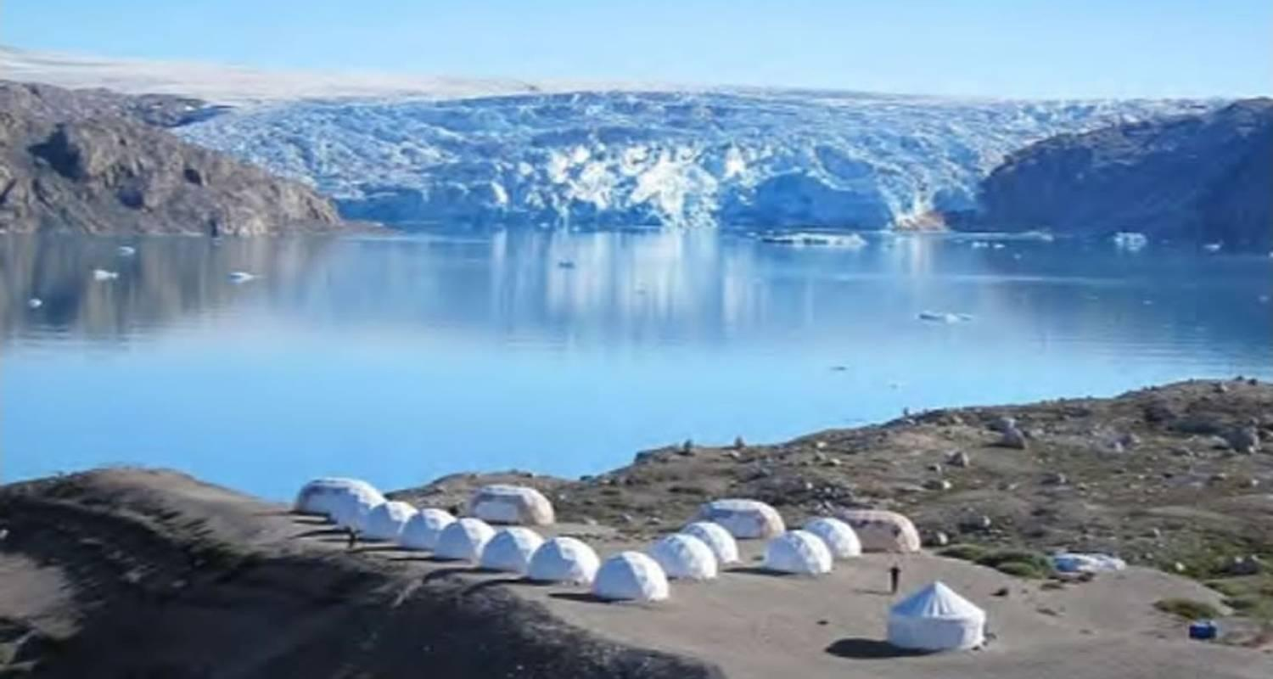

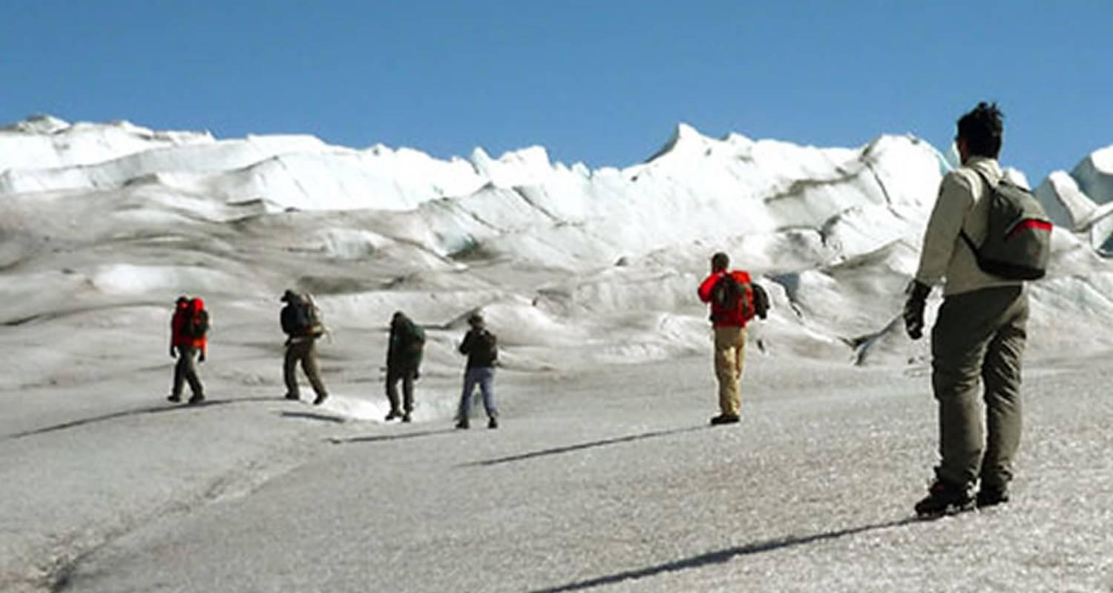

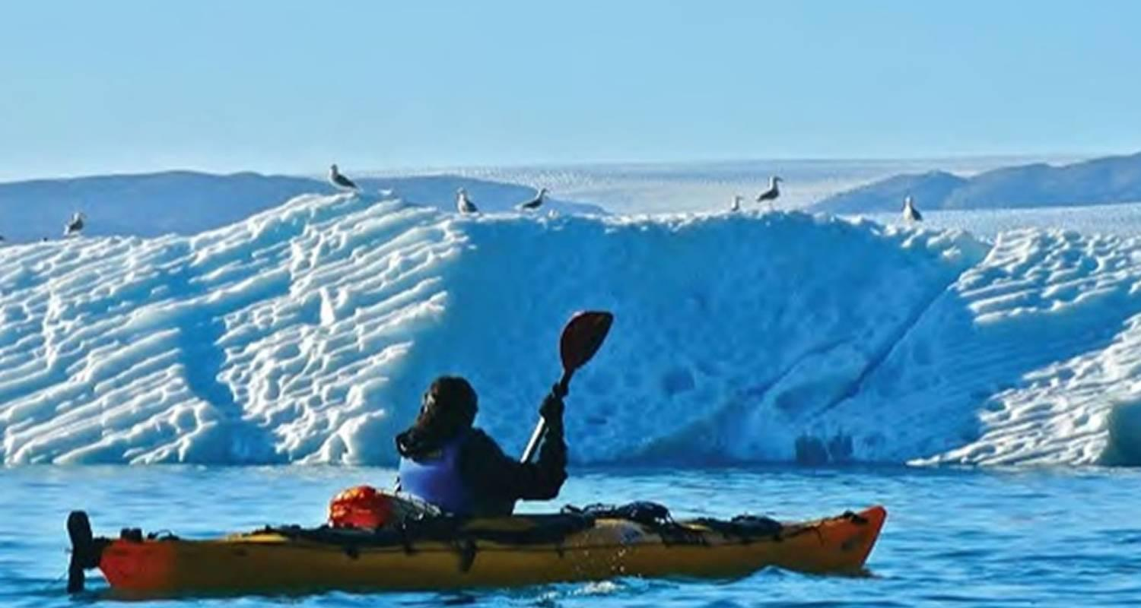

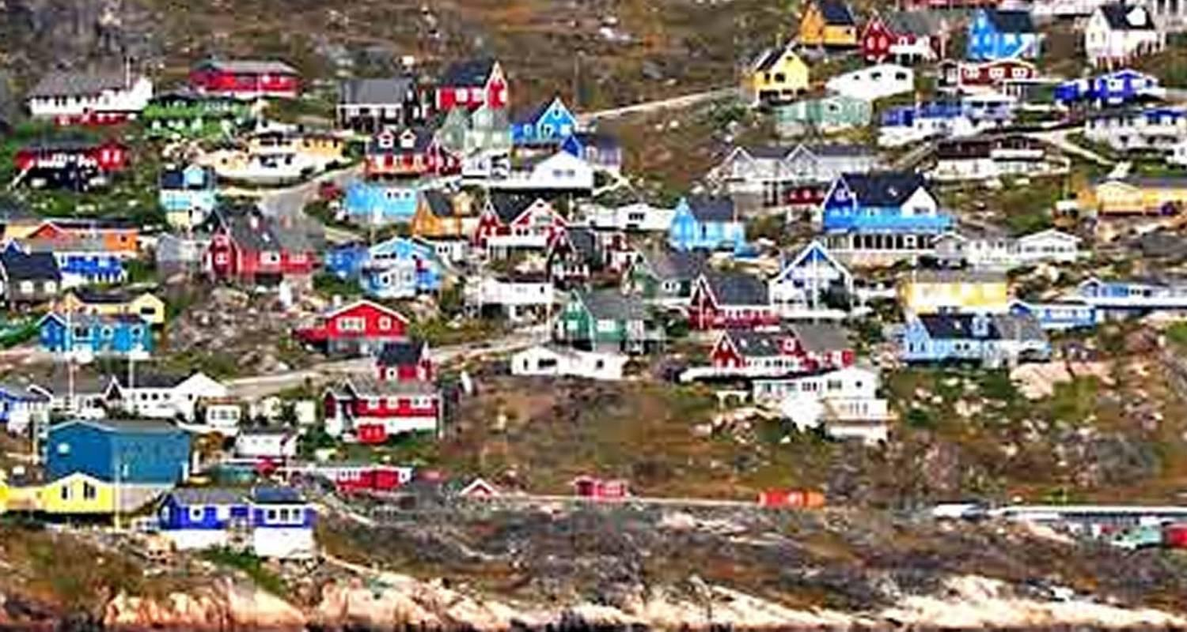

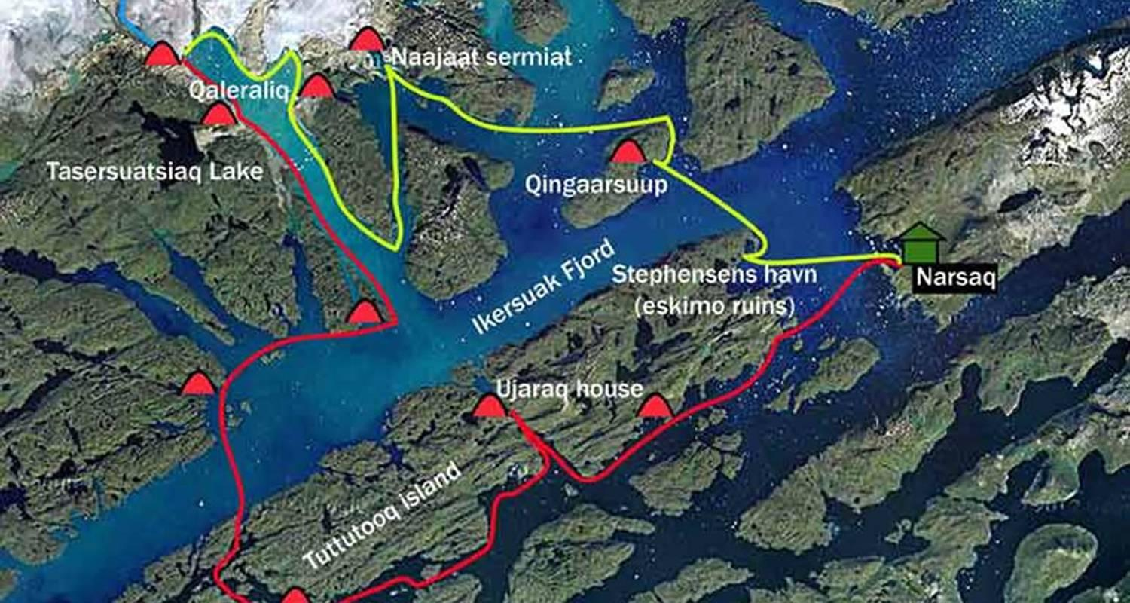

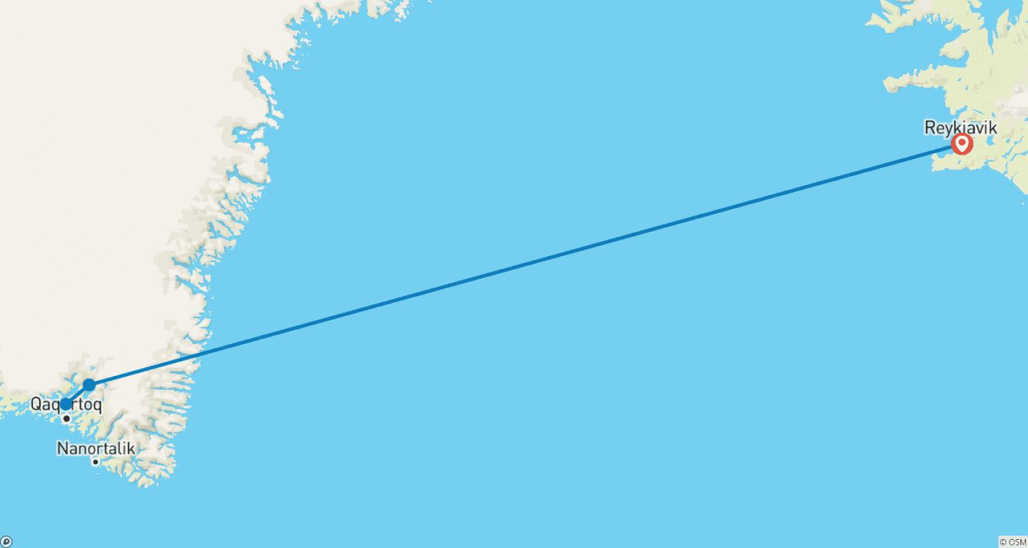

Tour ID: 260122  
Tour Name: Elemental Iceland – Circular Saga from Reykjavík

Tour destinations: ['Reykjavik', 'Snæfellsnes', 'Isafjordur', 'Akureyri', 'Husavik', 'Dettifoss', 'Blue Lagoon']

Tour destinations images:

